SUBCOURSE EDITION
MM4610 6

EXPLOSIVE
ORDNANCE DISPOSAL



EXPLOSIVE ORDNANCE DISPOSAL
EDITION 6
5 CREDIT HOURS

TABLE OF CONTENTS

Page

Table of Contents i

Introduction iii

Grading and Certification Instruction iv

Pretest (Performance-Based Examination is the Pretest) v

Lesson 1: Coordinate EOD Efforts with Outside Agencies 1

Lesson #1 Self-Test 10

Lesson #1 Self-Test Answers. 12

Lesson 2: Plan Chemical Disposal Operations 13

Lesson #2 Self-Test 35

Lesson #2 Self-Test Answers. 38

Lesson 3: Direct EOD Support of Range Clearance Operations. 41

Lesson #3 Self-Test 57

Lesson #3 Self-Test Answers 60

Lesson 4: Direct/Advise on Search Operations for Improvised
Explosive Devices (IED) 61

Lesson #4 Self-Test 77

Lesson #4 Self-Test Answers 80

Lesson 5: Identify Limitations on Authority of a Non-Commissioned
Officer Serving as Acting Commander 81

Lesson #5 Self-Test 87

Lesson #5 Self-Test Answers 88

i

TABLE OF CONTENTS (Continued)

Page

Lesson 6: Plan Unit Deployment 90

Lesson #6 Self-Test 95

Lesson #6 Self-Test Answers 96

Lesson 7: Plan Minefield Breaching Operations 97

Lesson #7 Self-Test 107

Lesson #7 Self-Test Answers 108

Lesson 8: Prepare Technical Intelligence Reports 109

Lesson #8 Self-Test. 115

Lesson #8 Self-Test Answers 116

ii

INTRODUCTION

This subcourse contains eight lessons on training management in explosive ordnance disposal units. The lessons are:

Lesson #1. Coordinate EOD Efforts with Outside Agencies

Lesson #2. Plan Chemical Disposal Operations

Lesson #3. Direct EOD Support of Range Clearance Operations

Lesson #4. Direct/Advise on Search Operations for Improvised Explosive Devices (IED)

Lesson #5. Identify Limitations on Authority of a Non-Commissioned Officer Serving as Acting Commander

Lesson #6. Plan Unit Deployment

Lesson #7. Plan Minefield Breaching Operations

Lesson #8. Prepare Technical Intelligence Reports

Supplementary Training Material Provided - None

Material to be Provided by the Student - None

Material to be Provided by Unit or Supervisor - None

Five credit hours will be awarded for successful completion of this subcourse.

iii

LESSON 1

OBJECTIVE: Coordinate EOD Efforts with Local Law Enforcement Agencies, Nuclear/Chemical Incident Control Teams, and Other Agencies

TASK: Upon completion of this lesson you will be able to coordinate EOD efforts with outside agencies.

CONDITIONS: Given this booklet and a pencil.

STANDARDS: Correctly answer all the questions on the Lesson #1 self-test. You must get 100% on the lesson self-test before you take the subcourse examination.

REFERENCES: FM 9-15
AR 50-5
AR 75-15
AR 50-6

1

LESSON 1

COORDINATE E.O.D. EFFORTS WITH OUTSIDE AGENCIES

Introduction

In this lesson you will learn how to coordinate EOD efforts with outside agencies.

There are 4 enabling objectives in this lesson. You must know how to do all 4 of these objectives.

OBJECTIVE ASSIST LOCAL LAW ENFORCEMENT AGENCIES IN EOD OPERATIONS
1

OBJECTIVE SUPPORT A NUCLEAR/CHEMICAL INCIDENT CONTROL TEAM DURING A
2 NUCLEAR/CHEMICAL ACCIDENT

OBJECTIVE RESPOND TO A REQUEST FOR RSP OR DISPOSAL OF NUCLEAR
3 WEAPONS

OBJECTIVE STORE HAZARDOUS ITEMS, MATERIALS, AND IED COMPONENTS
4

2

OBJECTIVE ASSIST LOCAL LAW ENFORCEMENT AGENCIES IN EOD OPERATIONS
1

1. EOD personnel assist public safety and law enforcement agencies when they have no EOD capability or their capability is over-extended. The control detachment will coordinate the request.

2. The responding EOD personnel may:

a. Function as Technical Consultants or Advisors. Assistance may be given civil authorities in the interest of public safety. When delays would endanger life or cause injuries, commanders are authorized to render such assistance as necessary to prevent injury or death. An immediate report of actions taken will be telephoned, through channels, to the Army Operations Center.

b. Attempt Render Safe Procedures. Army personnel may not attempt render safe procedures if that service aids or assists in a civilian criminal investigation. If authorized by the appropriate commander, Army personnel could assist in locating and disarming an explosive device if the facts do not assume assisting in a criminal investigation.

c. Assist In or Perform Disposal of Hazardous Residue. Emergency transportation and disposal of chemical surety material in the public domain is authorized only when the health or safety of any person is clearly endangered.

3

OBJECTIVE PROVIDE SUPPORT TO A NUCLEAR/CHEMICAL INCIDENT CONTROL TEAM
2 DURING A NUCLEAR/CHEMICAL ACCIDENT

1. Great care is taken in the handling of nuclear and chemical weapons and components. But, accidents can occur. The hazards present at an accident must be eliminated as soon as possible because of the destructive capabilities of these weapons. Special teams (Chemical Accident/Incident Control (CAIC) and Nuclear Accident/Incident Control (NAIC)) are ready at all times to respond to any accident situation. We will discuss the make-up of these teams and the important role EOD plays in their operations.

2. The NAIC team consists of:

a. On-scene Commander (OSC) - Normally a general officer. He commands all emergency forces and directs all operations at the scene.

b. Nuclear Accident and Incident Control Officer (NAIC). Normally, a field grade officer. He is responsible at the scene for the duties of the on-scene commander until he arrives.

The NAICO staff includes a judge advocate, public affairs officer, medical representative, and provost marshal. Additional staff will be called on as needed.

c. Supporting teams:

(1) EOD team

(2) Alpha team

(3) Medical team

(4) Physical security teams

(5) Nuclear-Biological-Chemical (NBC) Radiological Control (RADCON) teams

(6) DOD and DOE NAIC assistance teams

(7) Additional support elements as required

3. With this many people at the accident scene you can see how important it is to coordinate the EOD activities with the other supporting teams. The NAICO and staff handles the coordination. During the early stages of the incident, the EOD officer will be with the initial entry and work party. The EOD CP supervisor relays all necessary information to the coordinators and informs the EOD commander of decisions made by them as the on-scene commander.

4

To fill the EOD CP supervisor's job you must be thoroughly familiar with the EOD requirements at the accident scene. The EOD team responsibilities as outlined in AR 50-5 are:

a. Identify weapons and determine their condition.

b. Conduct RSP and DP when necessary and authorized by the on scene commander.

c. Collect classified components and associated material and return them to the OSC. Request disposition instructions of hazardous materials from the OSC.

4. Once the EOD mission is completed the OSC may use the EOD personnel to aid other teams.

5. The CAIC team is very similar to the NAIC team. It consists of:

a. On-scene commander (OSC) - Directs all operations at the scene.

b. Chemical Accident and Incident Control Officer (CAICO):

(1) Acts as the representative of the OSC when he is not present at the accident site.

(2) Coordinates all clean-up activities of his staff and supporting teams.

c. The CAICO staff will consist of at least the following:

(1) Assistance CAICO operations officer

(2) Provost marshal

(3) Public affairs officer

(4) Communications Officer

(5) Staff Judge Advocate

(6) Engineer Officer

(7) Medical Officer

(8) Safety Officer

(9) Chaplain

5

d. Staff members will provide guidance to the CAICO when situations come up in their particular fields. These situations include such items as claims against the government, crowd control, security, public information, etc.

e. In addition to the staff, the CAICO will have several supporting teams working under his/her direction. As a minimum, these supporting teams consist of:

(1) EOD Team

(2) NBC Team

(3) Medical Team

(4) Physical Security Team

(5) Communications Team

6. You will work most closely with the NBC team. Many of their responsibilities overlap the EOD mission. So EOD may be required to assist the NBC team once the EOD mission is finished. Coordination will be handled by the CP supervisor.

7. Now it is time to review the EOD mission. Keep in mind the CAICO team is made up for peace time situations only. In a combat environment the EOD team will follow the chemical/biological procedures outlined in FM 9-15.

a. Upon notification of a CB accident/incident, the EOD team will respond by the fastest means available.

(1) If the team is the first military to arrive, the EOD officer will take control until relieved by the OSC, CAICO, or other senior military.

(2) Determine, if possible, the extent of hazard involved, start emergency measures to limit the spread of the hazard and protect life.

(3) Identify and mark the initial exclusion area and downwind hazard area. The decision to adjust the hazard areas will be made by the CAICO from information supplied by the EOD CP supervisor.

(4) Start rescue operations for injured people in the hazard area. They should be evacuated quickly to the control point on the hotline.

(5) Set up an initial command post in an uncontaminated area. Check the area IAW the procedures in FM 9-15.

(6) Set up and operate a personnel decontamination station (PBS) if the NBC team has not arrived on the scene. The emergency PDS will suffice for unit personnel.

6

b. When the CAICO arrives on the scene the EOD CP supervisor will brief him on all actions taken by the EOD team. Any other needed actions will be recommended to the CAICO for his decision.

c. After Render Safe Procedure (RSP) is completed, the EOD team may assist other elements of the CAICO- team.

7

OBJECTIVE DETERMINE AUTHORITY TO RESPOND TO A REQUEST FOR RSP
3 OR DISPOSAL OF NUCLEAR WEAPONS

1. AR 75-15, Chapter 4 requires at least two EOD qualified personnel, one officer and another individual (officer or enlisted) to perform any nuclear weapons RSP and disposal procedures.

2. As an NCO serving as acting commander you cannot under any circumstances perform a RSP or DP on a nuclear weapon. If your unit has no EOD qualified officer it is "non-nuclear operational" IAW Chapter 4, AR 75-15. However, an EOD unit which does not have an officer may respond to a nuclear accident/incident when an EOD qualified officer is assigned for concurrent response with the unit.

3. The above restriction also applies to the EOD component of a NAIC response force.

8

OBJECTIVE STORE HAZARDOUS ITEMS, MATERIALS, AND IED COMPONENTS
4

1. Storage of hazardous items, materials and Improvised Explosive Device (IED) components will be IAW the following:

a. For Federal Agencies - Storage of these components and bulk explosives is authorized under the provisions of the Economy Act of 1932.

b. For Non-Federal Agencies - In the interest of public safety, provided no out-of-pocket use of Army funds is necessary, explosive components and/or materials may be stored for periods of 90 days or less. Items may be stored for an additional 90-day period upon approval of the major commander concerned.

c. A chain of custody can only be maintained for use in a military court.

9

Lesson #1 Self-Test

Circle the letter of each correct answer.

1. At the scene of a nuclear accident, who handles the coordination of EOD activities with the other supporting agencies?

a. the EOD officer-in-charge

b. the NAICO and staff

c. the DOD NAIC assistance team

2. Classified components and associated material should be:

a. returned to the OSC

b. disposed of according to EOD standard operating procedure

c. given to the alpha team

3. Once the EOD mission is finished, the EOD team:

a. will leave the scene immediately

b. may be required to assist the NBC team

c. should report to the provost marshal

4. In a combat environment:

a. the CAICO team will function much the same as in peacetime

b. the EOD team will follow FM 9-15, Chapter 4

5. Hazardous items, materials, and IED components may be stored for non-federal agencies:

a. provided no out-of-pocket use of Army funds is necessary

b. only for periods of 90 days or more

6. If an EOD unit is requested to maintain a chain of custody of hazardous items, materials, and IED components for possible use in federal court:

a. the request must be denied

b. authorization must be given by the civil authority in charge

c. the chain of custody must be maintained by a military court

10

7. A situation has arisen which requires you to respond to a nuclear accident. You are the Acting Commander and must decide whether you can respond. Can you respond? If you do respond, what are the restrictions?

11

Lesson #1 Self-Test Answers

1. b
If you got this wrong, go back to page 4 and review.

2. a
If you got this wrong, go back to page 5 and review.

3. b
If you got this wrong, go back to page 6 and review.

4. b
If you got this wrong, go back to page 6 and review.

5. a
If you got this wrong, go back to page 9 and review.

6. a
If you got this wrong, go back to page 9 and review.

7. Without an officer, you cannot respond to a nuclear incident/accident. In order to respond, an officer from EODC or another detachment must be provided.

If you got this wrong, go back to page 8 and review.

12

LESSON 2

OBJECTIVE: Plan Chemical Disposal Operations

TASK: Upon completion of this lesson you will be able to plan chemical disposal operations.

CONDITIONS: Given this booklet and a pencil.

STANDARDS: Correctly answer all the questions on the Lesson #2 self-test. You must get 100% on the lesson self-test before you take the subcourse examination.

REFERENCES: FM 9-15
TM 3-250
AR 50-21
TM 3-220

13

LESSON 2

PLAN CHEMICAL DISPOSAL OPERATIONS

Introduction

In this lesson you will learn how to plan chemical disposal operations. There are 5 enabling objectives in this lesson. You must know how to do all 5 of these objectives.

OBJECTIVE PREPARE FOR CHEMICAL DISPOSAL OPERATION
1

OBJECTIVE SELECT FINAL DISPOSAL AREA
2

OBJECTIVE DECIDE METHOD OF DISPOSAL
3

OBJECTIVE SET UP A PERSONNEL DECONTAMINATION STATION
4

OBJECTIVE DETERMINE DECONTAMINANTS TO BE USED
5

The guidance for EOD in this area changes very quickly. We will discuss the very general guidance concerning these areas. Your control detachments and/or FORSCOM EOD section will apply this guidance to specific situations.

14

OBJECTIVE PREPARE FOR CHEMICAL DISPOSAL OPERATION
1

1. Currently, all commercial chemical incidents will be handled by local or state authorities. If the state does not have the resources available to take care of the incident, it will request assistance from the federal government.

2. Route of request:

a. The governor's office will request assistance from the EPA regional office.

b. The EPA will assign an on-scene coordinator who will assess the situation, determine the assistance required and report to EPA headquarters.

c. The Federal EPA HQ is the lowest agency that can request assistance from EOD. The request will come through channels to the control detachment. They will direct the EOD team to respond to the incident. Specific authority for disposal of toxic agents/munitions must be obtained before conducting disposal operations. This restriction does not apply to emergency situations or to incidents where final disposal is effected by decontamination of the site (AR 75-15, Chapter 3).

3. A disposal area should be suitable for demolition, burning, and other disposal methods. Sites selected must be located at least 800 yards or 732 meters from inhabited buildings, public railways, highways, and supply points. Disposal areas generally are small and should be located centrally so as to be readily accessible to the units using them. The entrance to the site should be accessible to vehicles. Soft ground is preferred for demolition pits and burning grounds. Rock strata should be avoided since it may transmit earth shock for several miles. Natural barriers such as surrounding bluffs or heavily wooded areas are desirable to blanket the blast effect. The area must be cleared of combustible material and brush within a radius of 200 feet (60 meters). A bunker or revetment for protection of personnel from fragment or blast effects is desirable. Disposal areas should be marked in accordance with NATO Standardization Agreement (STANAG) 200 (app B). It is seldom practicable to maintain guards at the site except when destruction is underway.

4. Actions on site:

a. The EPA representative on the scene will brief the EOD team upon its arrival. The briefing will include such items as:

(1) Extent of assistance that EOD will provide.

15

(2) Any special hazards or special equipment required.

(3) The EPA will determine the least environmentally harmful method of disposal.

(4) Civil Support Release and Reimbursement Agreements are not required. Reimbursement is funded under an inter-agency agreement between EPA and DOD.

16

OBJECTIVE SELECT FINAL DISPOSAL AREA
2

The following factors must be considered when selecting a disposal area for CB munitions.

1. Prevailing wind direction. Consideration must be given to the direction of prevailing winds, so that toxic vapors will not be carried into inhabited areas occupied by friendly troops. The site must be downwind of any population center.

2. High, open terrain. This type of terrain is preferred to facilitate the dispersal of any agent vapor cloud that might be formed. Agent clouds will tend to seek low areas and will move slowly in forests or heavy vegetation.

3. Maximum distance from critical areas. In addition to being downwind (based on-prevailing winds) the site should be located as far as practical from ammunition storage areas, inhabited buildings, training areas, highways, railroads and airports in respect to fragmentation hazards as well as agent vapor cloud travel.

4. Cleared area. A minimum radius of 60 meters should be clear of combustibles. This is to prevent uncontrolled burning of possibly contaminated surfaces. This area should be designated as a restricted area and should be fenced and posted if it is to be used on a recurrent basis.

5. Warning devices. Both visible and audible warning devices are required, i.e., range flag, klaxon horn, or siren.

6. Exclusion area. An exclusion area must be established to prevent unprotected personnel from encountering agent vapors or clouds during active disposal operations. The size of this area can be predetermined and a limit established for the amount and type of agent that may be destroyed or the size may be determined for each disposal operation. All normal entrances and access routes into the exclusion area must be blocked and marked.

7. Aid station. Aid station, PDS and firefighting equipment must be readily available during each disposal operation. The aid station and the PDS may be minimal if more extensive facilities are located nearby.

8. Bunker or revetment. A bunker or revetment should be provided for protection of operating personnel from fragments.

9. Communications. Communications should be established from the disposal area to firefighting and medical facilities.

17

10. Protective clothing. Personnel will wear protective clothing commensurate with the hazards of the agents being destroyed. Full protective clothing with impermeable accessories and mask should be worn for the disposal of toxic chemical and biological agents.

11. Additional peacetime disposal requirements. During peacetime, there are greater restrictions on the method of disposal:

a. Dumping in the sea is employed only with specific approval of Congress.

b. Land burial will not be used without the specific approval of Congress.

18

OBJECTIVE DECIDE METHOD OF DISPOSAL
3

1. Disposal method will be dictated by the type and quantity of agent. Use the following table to determine which method to use for each type of agent.

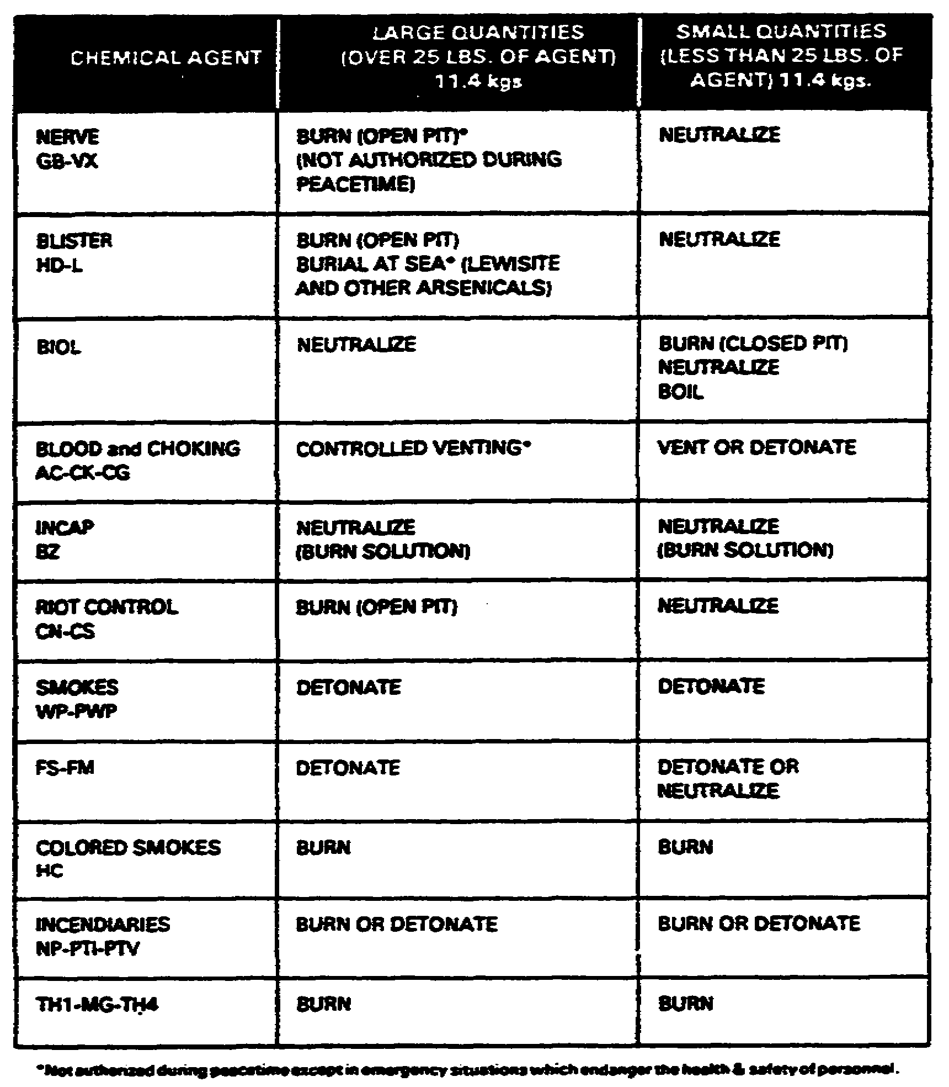

2. DISPOSAL BY BURNING

a. Open Pit Burning. Burning can be employed to dispose of blister (except arsenicals), nerve agents, incendiary, riot control, smoke, and flame fillings of munitions. Burning should be accomplished in an open pit or trench for toxic chemical agents.

19

(1) The pit should be deep enough to allow a minimum depth of 0.6 meter (2 ft) of combustible material, such as wood, to be placed under the item to be destroyed, and a minimum distance of 0.3 meter (1 ft) from the item to the top edge of the pit. Deeper pits should be used for larger quantities of agent, thus permitting additional burning material to be used and consequently longer and hotter burning. Deeper pits will reduce the fragmentation hazard from heavy cased ordnance.

(2) The pit must be wide enough to permit the use of a minimum of 1 meter (3 ft) of combustible material on each side of the items.

NOTE: Gasoline is not recommended for this purpose due to the low flashpoint and the susceptibility to premature ignition from a small spark.

(3) In order to aid rapid ignition and to assist the combustion, used motor oil, thickened flame fuel, or diesel fuel should be spread over the combustible material.

(4) Cased munitions must be opened with a small explosive charge simultaneously with the ignition of the burning pit. This is done to permit a slow release of the agent into the flame. If the munition is not opened or vented, a mechanical explosion (due to the buildup of agent pressure) may occur, resulting in a sudden release of the agent and incomplete destruction of the toxic properties by the fire. The major consideration is to open the munition with a small puncturing charge that will not propel the munition out of the burning pit and to release the smallest amount of agent possible until the pit is completely ignited and high temperatures develop.

(5) The venting charge must be arranged so as to avoid a high order detonation of the burster.

(6) The explosive venting charge detonation and pit ignition must be done simultaneously and remotely. Gasoline in small, closed containers (plastic jugs or metal cans) exposed in the pit will provide an excellent means of assuring rapid and complete ignition. These are easily assembled and can be integrated with the explosive train used to open the munition. Three or four igniters of this type should be incorporated in the burning pit. The fireball created by these igniters will help to destroy any agent released by the venting charge. Glass bottles should not be used as containers for the gasoline. They may break if dropped and the broken glass will be a hazard to protective footwear.

20

(7) The disposal of nerve and blister agents by burning will create a significant downwind hazard to unprotected personnel. The extent of the actual hazard cannot be accurately computed since it will depend on the efficiency of the burning pit and the ambient weather conditions. Using the ABC M2 calculator, the maximum downwind hazard distance and cloud width may be calculated by assuming a total release of all the agent. If the disposal operation is successful, i.e., the munition is properly opened and the pit burns vigorously, a high percentage of the agent will be destroyed and the actual hazard area will be much less than the maximum calculated. If however, the operation is not completely successful, the computed downwind hazard area will have provided an adequate exclusion area for unprotected personnel downwind.

(8) After the fire has burned out and the pit has cooled for a minimum of 12 hours, the pit, its contents, and the surrounding area must be checked for residual contamination, explosives, or any other hazardous items.

(9) During peacetime, nerve agents cannot be disposed of by open pit burning. Specially approved DARCOM procedures will be established covering peacetime disposal of nerve agents.

(10) Riot control, incendiary and colored smoke agents may also be disposed of by burning. The quantity that can be destroyed in a single operation is generally limited only by the type of agent and the downwind travel of the agent/smoke cloud. Burning large stacks of small incendiaries should be avoided since explosions and scattering of incompletely destroyed munitions may result.

(11) The advantages of burning as a method of disposal are that the hazard to operating personnel is small and large quantities can be disposed of economically.

b. Closed Pit Burning. Small biological munitions can be effectively destroyed by burning with thermate incendiaries in a closed pit.

(1) The pit should have a minimum depth of 1 meter (3 feet) and should be large enough to accommodate the munition being destroyed.

(2) Secure some type of a thermate incendiary device, preferably two or more thermate grenades on top of the munition. Dual prime for remote electric or nonelectric firing and place in bottom of the pit.

21

(3) Secure a 4 foot length of safety fuze to the incendiary device, opposite the primed end, so that it will extend at least 1 foot above the surface after the pit is filled with earth. This "telltale" device will eventually indicate that burning has occurred.

(4) Place a board or metal plate of sufficient length and width to cover the munition, 6 inches above the grenade/munition package.

(5) Refill pit, tamp earth and ignite the incendiary device.

(6) The operation will be successful if the "telltale" safety fuze that was secured to the incendiary device burns and no smoke is observed leaving the pit.

(7) The operation will be unsuccessful if the safety fuse on the surface of the ground does not burn. Wait at least 30 minutes before investigating the malfunction then open the pit and check all connections.

(8) If smoke is observed escaping from the pit and the "telltale" safety fuse on the surface of the ground functions properly, decontaminate the immediate area around the pit with 10 percent solution of caustic soda or calcium hypo chlorite (a 30-meter radius will be sufficient).

3. DISPOSAL BY VENTING

a. Venting, or release to the atmosphere, is a method used to dispose of agents or hazardous chemicals (TM 3-250) with a high volatility (normal physical state in a gas) such as CG, CK and AC. Nerve agents will not be vented.

(1) Venting normally will be limited to small quantities of agents or large quantities under controlled release conditions. When the venting site is distant from inhabited areas, greater quantities may be released, provided that safe downwind area requirements are met as determined by the M2 calculator.

(2) Venting may be accomplished by puncturing the munition with an explosive shaped charge, by opening filler plugs or venting valves, or by drilling a hole in the munition. Prior to drilling a hole in a munition, it is recommended that the munition be cooled to as low a temperature as possible. Dry ice and alcohol slurry is very effective as refrigerant. Water, ice and salt mixtures are also effective. Cooling will significantly reduce the vapor pressure, and the drill operator will not be subject to high concentrations of toxic vapor when the munition casing is penetrated. The munition should be packed in the coolant material for about an hour prior to drilling.

22

(3) Venting permits maximum salvage of agent containers, it is economical and the explosive components are not affected. Its major disadvantage is the limitation of quantity due to the large downwind hazard area used in conjunction with the venting of small munitions containing CG or CK. In this case, disposal by detonation may be appropriate.

4. DISPOSAL BY DETONATION

Some smoke and incendiary filled munitions can be disposed of using a method similar to that used for high explosive items. This method is practical for disposing of white phosphorus filled munitions. In some remote locations, toxic chemical munitions may be detonated where they are found. But be sure to observe downwind hazard restrictions. The detonation method may be used together with the venting of small munitions containing CG or CK. In this case, place enough explosives on or under the munition rather than puncturing the casing. This method may be proper when the integral explosive components cannot be removed. During wartime, this may be the only practical way to dispose of all types of CB agents. If possible, use at least 2.25 kgs (5 pounds) of explosives for each .45 kg (1 pound) of agent.

5. DISPOSAL BY NEUTRALIZATION

a. Neutralizing or detoxifying chemical agents with a chemical decontaminant is the preferred method to dispose of small amounts of chemical agents of 11.4 kgs (25 pounds) or less. It is an excellent way to dispose of small amounts of biological agents and all amounts of incapacitating agents. In addition, with special equipment neutralization can be used to dispose of larger amounts of CB agents.

b. Use at least 2 gallons of 10 percent neutralizing solution for each pound of agent. Caustic soda solutions are very effective on biological agents, chemical agents, GB; AC, CK, CG, CN, and acid smokes FS and FM. Calcium hypochlorite solutions are most effective to nerve agent VX, vomiting agents such as DM, and biological agents. Alcoholic caustic solutions should be used for neutralizing BZ and CS. Mustard agents (such as HD) require 4 gallons of neutralizing solution to each pound of agent. Calcium hypochlorite solutions are effective on blister agents.

c. When conducting neutralizing operations, place the right amount of neutralizing solution in a heavy-gaged steel container such as a 55-gallon drum. Regulate the flow of agent into the container through a valve and pipe system or by slow pouring. Stir the solution as the agent flows into the container to mix the agent with the neutralizing solution.

23

6. DISPOSAL BY BOILING

a. Most biological agents can be destroyed in a short period of time by boiling water temperatures. Small biological munitions can be effectively neutralized by this type of disposal operation.

(1) Support the munition in an open container so that it does not touch or rest directly on the bottom of the container.

(2) Fill the container with water to a level about 12 inches above the munition.

(3) Heat the water to the boiling point and continue vigorous boiling for 2 1/2 hours. Be sure to maintain the water level in the container during the operations.

(4) The explosive components will not be adversely affected by the temperature of boiling water.

(5) After completion of the 2 1/2 hour boiling period, the munition should be allowed to cool, and the explosive components may be detonated.

7. DISPOSAL AT SEA

a. Disposal by dumping at sea requires approval of Congress.

8. DISPOSAL BY LAND BURIAL

a. This method of disposal will not be used if disposal is possible by other means, since underground water sources may be contaminated or the land area may become the site of future construction. Land burial is usually considered only a stopgap or holding measure to reduce or contain hazards until another method of permanent disposal can be arranged. Burial of toxic agents is employed only after prior approval of Congress.

24

OBJECTIVE SET UP A PERSONNEL DECONTAMINATION STATION
4

1. GENERAL

a. This material contains an example of a PDS recommended for emergency use by EOD units. Normally a NBC team will set up and operate a decontamination station which is capable of decontaminating all personnel who have become contaminated as a result of a chemical or biological incident. In an emergency situation, the EOD unit or team must be capable of decontaminating its own personnel and equipment.

b. The actual arrangement of individual stations will depend on the type and amount of agent involved. Four principles should be followed when establishing the PDS:

(1) Move into the wind as undressing progresses.

(2) Decontaminate and remove the most heavily contaminated items of apparel first.

(3) All articles of clothing worn at the accident/incident site will be removed and deposited in appropriate containers.

(4) The protective mask and hood should be the last items removed prior to washing.

NOTE: Once protective mask and hood are worn in a contaminated area, they are considered an inseparable unit.

c. The hot line (see the figure on the following page) is an arbitrarily selected line separating the contaminated area from the contamination reduction area. It must be established in a clean area, upwind of the accident/incident, and must be a minimum of 50 meters downwind from the CP. The hot line should be as close to the accident/incident site as possible but must not be inside the fragmentation radius of the munition involved. All personnel and equipment entering and leaving the area are channeled through the control point on the hot line.

25

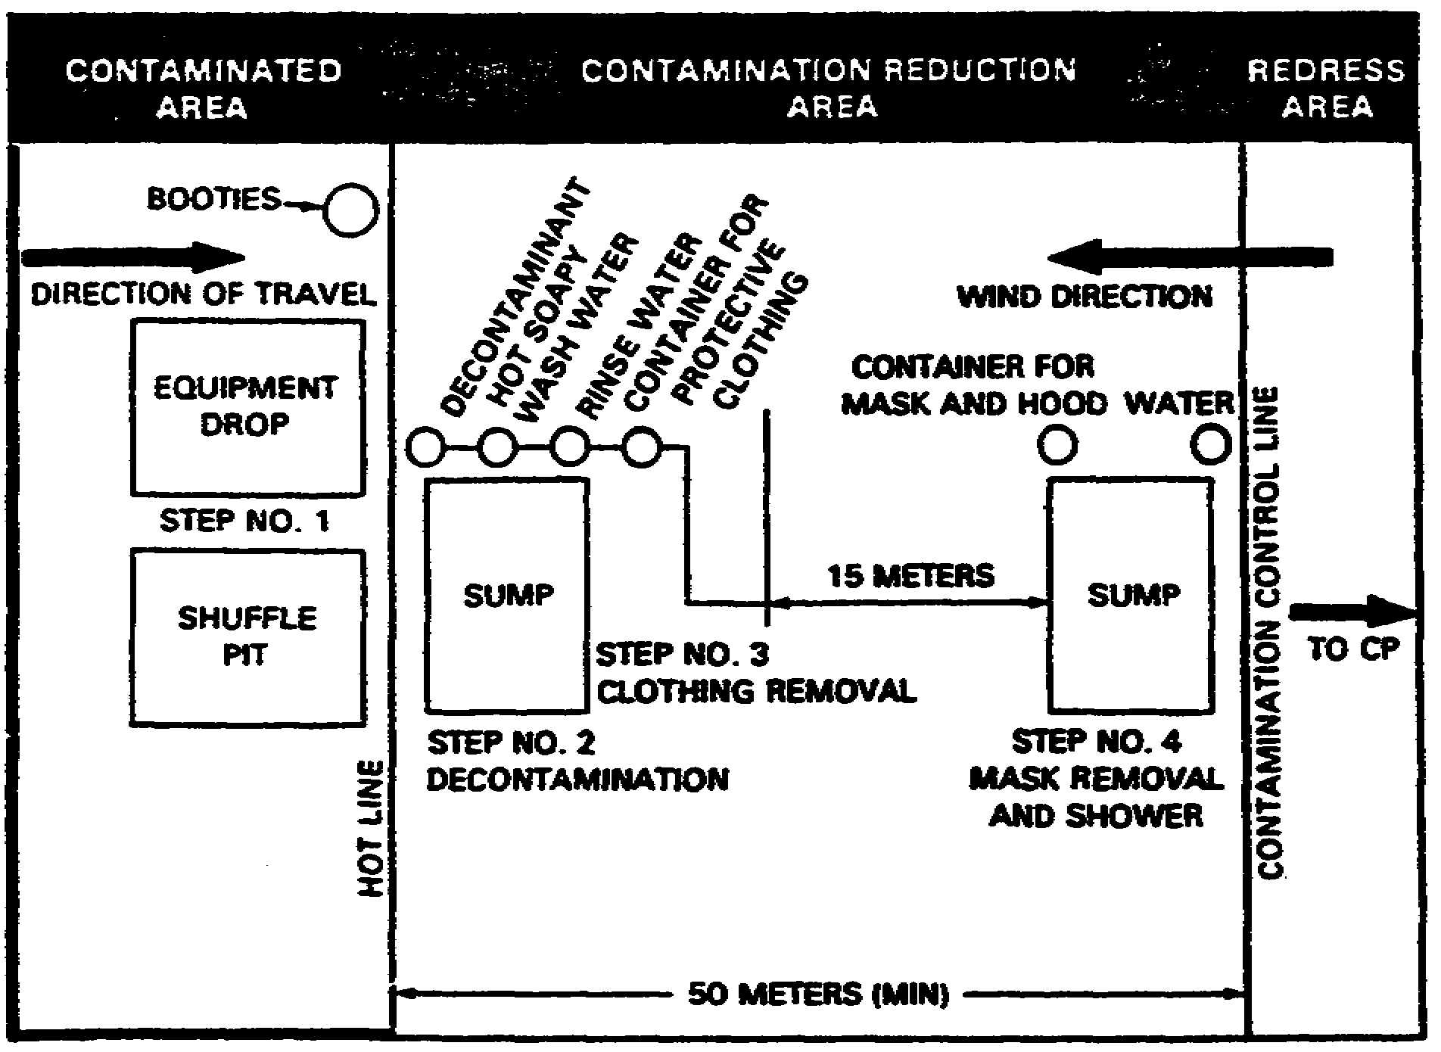

Figure 1 EOD Personnel Decontamination Station

d. The contamination reduction area may become hot by personnel returning from the accident/incident area; therefore the contamination reduction area will become contaminated once decontamination operations begins. Any contamination prior to the operation of the PDS in the contamination reduction area will be marked accordingly as a contaminated area.

e. The contamination control line is an arbitrarily selected control line separating the contamination reduction area from the clean area. The contamination control line acts as a control to prevent individuals with unacceptable levels of contamination from stepping into the clean area of the CP. It is also intended to prevent personnel from getting into the contamination reduction area (possibly contaminated) without proper protective clothing.

26

f. Depending on the situation, the following priorities for processing through the PDS should be established.

(1) Injured personnel

(2) Munitions

(3) Classified components

(4) Classified publications

(5) Personnel

(6) Masks

(7) Other equipment

g. A shuffle pit may be established in the incident side of the hot line if the EOD unit commander considers it necessary.

2. PROCEDURES

a. Step 1 - Equipment Drop.

(1) Equipment: Any material which will prevent the contaminated equipment from contacting the ground (plastic bags, oil cloth, etc.).

(2) Action: Place all equipment used at the accident/incident site on the protective material provided.

b. Step 2 - Decontamination.

(1) Equipment

(a) Containers, preferably sprayer type, for:

1. Decontaminant

2. Hot Soapy Water

3. Rinse Water

(b) Grate for sump

(c) Decontaminant in sump

(d) ABC M18A2 Detector Kit

(e) Antidote for agent(s) detected by IEP/WP.

27

(2) Action:

(a) Stand on grate over sump.

(b) Spray, pour, or brush individual's impermeable protective clothing with personnel decontaminant.

(c) Spray, pour, or brush individual with hot soapy water.

(d) Spray or pour rinse water on individual.

c. Step 3 - Clothing removal.

(1) Equipment: Container for protective clothing.

(2) Action: Remove all clothing, except protective mask and hood, and place in container provided.

d. Step 4 - Mask and hood removal and shower.

(1) Equipment:

(a) Container for protective mask and hood, e.g., plastic bag.

(b) Container for wash water, e.g., 5-gallon water can.

(c) Grate for sump.

(d) Towels.

(2) Action:

(a) Step onto grate, take deep breath, remove mask and hood, and place in container provided.

(b) Rinse head and upper body, resume breathing.

(c) Pour water over body and wash with soap.

(d) Rinse body.

(e) Proceed across contamination control line to redress area.

3. RECOMMENDED PROCEDURES FOR CLOSING OUT PERSONNEL DECONTAMINATION STATION

After team members have cleaned up the incident site, disposed of leaking munitions, and processed through the PDS, the PDS should be dismantled. (Shuffle pit, if used, may be disposed of by raking contents into the ground.)

28

a. One PDS assistant and other PDS assistants or team members as necessary, cross the hot line, collect equipment and other items from the equipment drop and pour decontaminating solution over the area.

b. They then proceed through the contamination reduction area of the PDS dismantling and collecting items in containers as they proceed. Each point is decontaminated by pouring decontaminating solution over it.

c. Contaminated clothing and equipment that has been collected should be disposed of as directed by on-scene-commander (AR 50-21). Contaminated items in plastic bags may be disposed of along with the leaking munitions, or they can be decontaminated using procedures in TM 3-220.

d. After the PDS is dismantled, a final check for contamination will be made. If contamination is found, contamination markers should remain until the area is decontaminated and cleared by the on-scene-commander, at which time the markers will be removed.

29

This page intentionally left blank

30

Practice Exercise #1

Circle the letter of the correct answer.

1. As NCOIC of a NBC team, you must set up a PDS for emergency use. Which of the following would be a correct plan?

a. Set up a hot line 30 meters downwind from the CP.

b. Set up a hot line as close to the accident/incident site as possible.

c. Do not allow injured personnel across the hot line and into the PDS.

d. Make sure the protective mask is deposited away from the protective hood.

2. The EOD unit commander has asked you to process EOD equipment and personnel through an emergency personnel decontamination station (EPDS). You should:

a. place all equipment used at the accident/incident site on protective material.

b. try to get a sprayer container for the hot soapy water and rinse water, but not the decontaminant.

c. have all personnel remove all clothing immediately.

d. not do anything to the individual's impermeable protective clothing.

3. To close out the personnel decontamination station, you should:

a. not cross the hot line after the last person has been processed.

b. pour decontaminating solution over the area.

c. make sure that contaminated items in plastic bags are never disposed of along with leaking munitions.

31

Answers to Practice Exercise #1

1. b

2. a

3. b

32

OBJECTIVE DETERMINE DECONTAMINANTS TO BE USED

Use the table below and on the following page to determine which decontaminants to use and how to use them.

DECONTAMINANTS FOR PERSONNEL IN PDS.

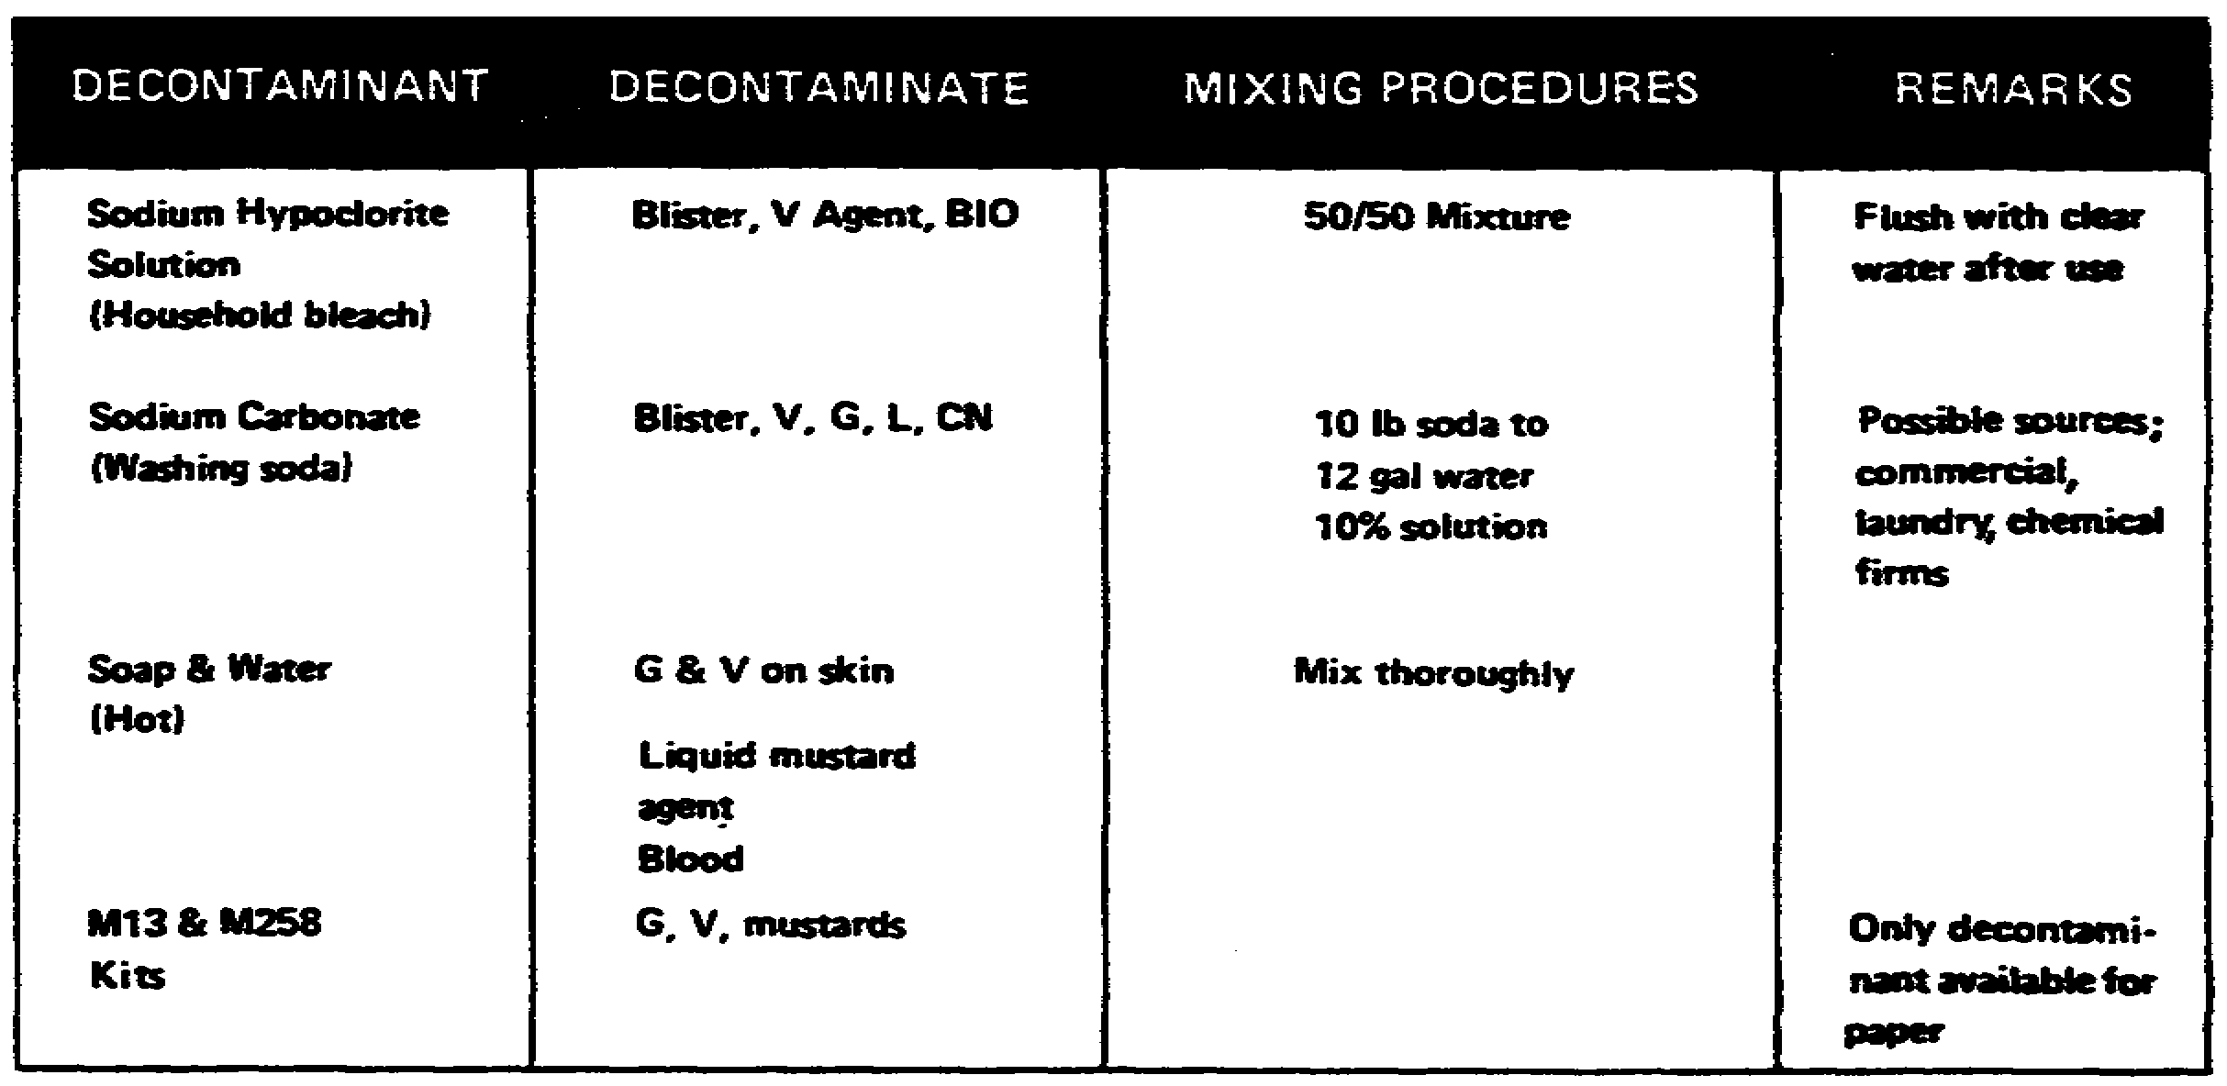

33

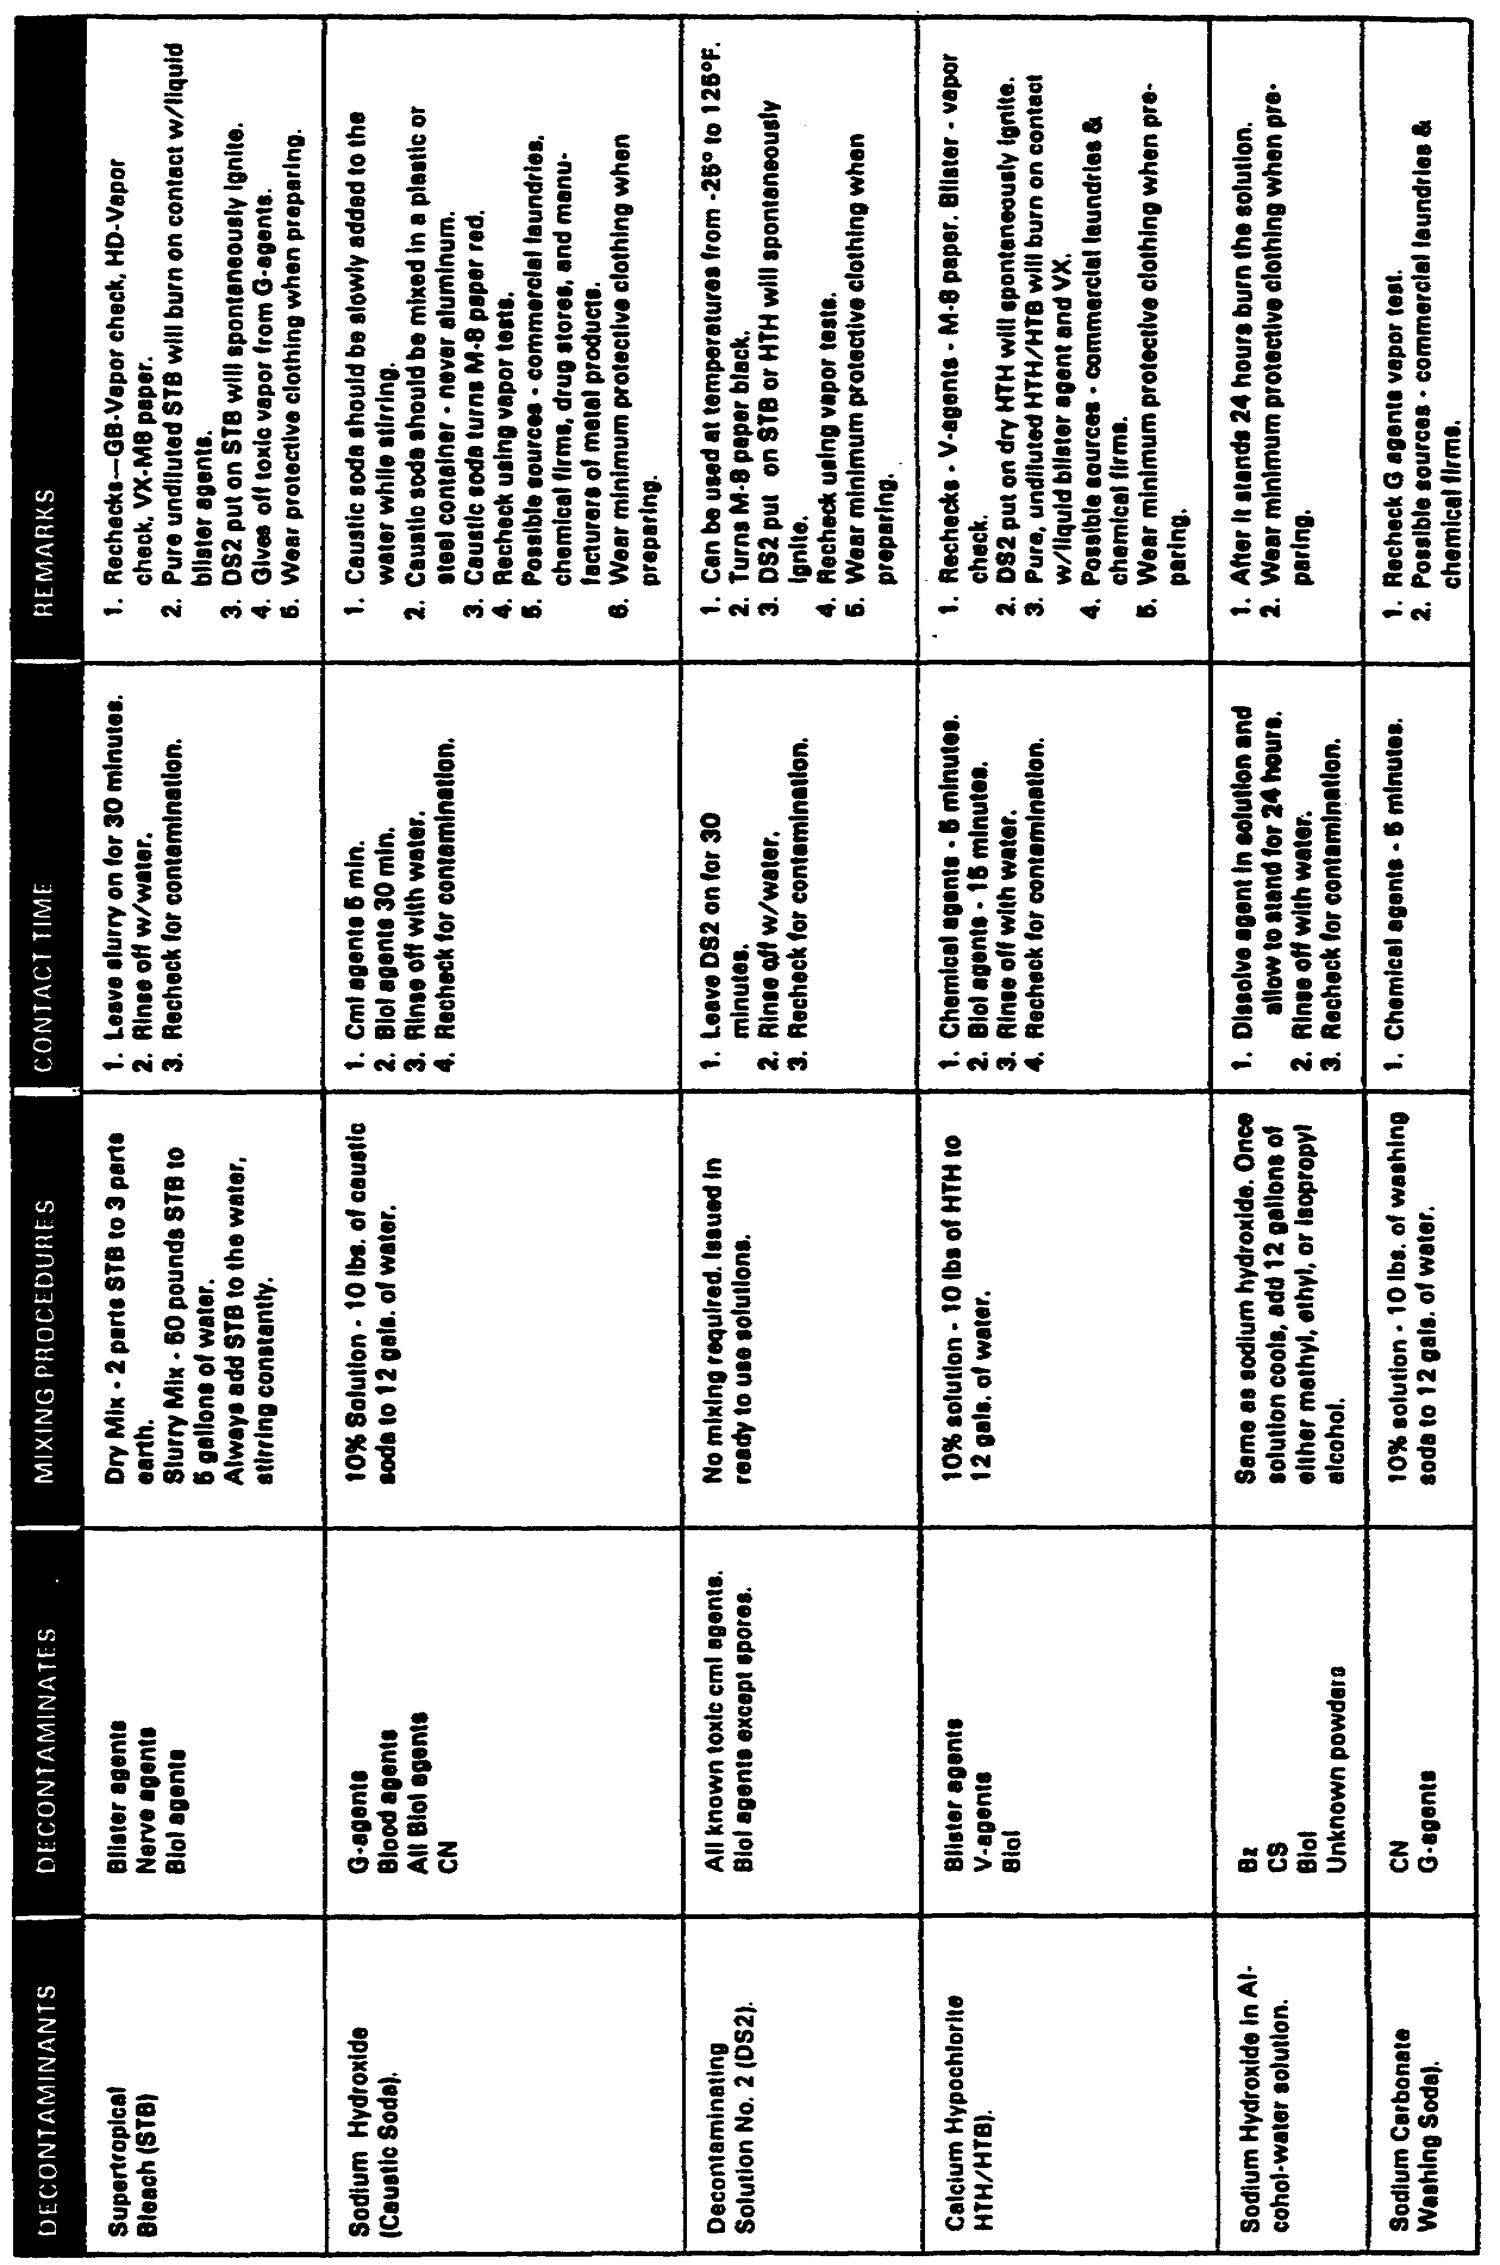

34

Practice Exercise #2

As assistant EOD Supervisor in an EOD Detachment, you must prepare a plan of disposal for this item in a peacetime situation.

Rocket, Gas, Non-persistent, 115m, M55, GB filled weight of agent filler is 4.88 kg.

Choose the best method of disposal and the decontaminants that you will use. Describe the mixing procedures for your shuffle pit and slurry mix that will be used in your Personnel Decontamination Station. Prepare a layout for the Personnel Decontamination Station (PDS) and label each item shown in your layout. Show the wind direction with respect to the personnel decontamination station.

Agent:

Method of disposal:

Decontaminant:

Mixing Procedures:

Contact time:

35

Answer to Practice Exercise #2

Rocket, Gas, Non-persistent, 115m, M55, GB-filled

Agent: GB

Method of disposal: Neutralize

Decontaminant: Sodium Carbonate Washing Soda

Mixing Procedures: Mix 10 pounds of washing soda to 12 gallons of water 10 percent solution

Contact Time: Leave solution on for 5 minutes, rinse with water. Recheck for contamination (vapor check).

See the layout below.

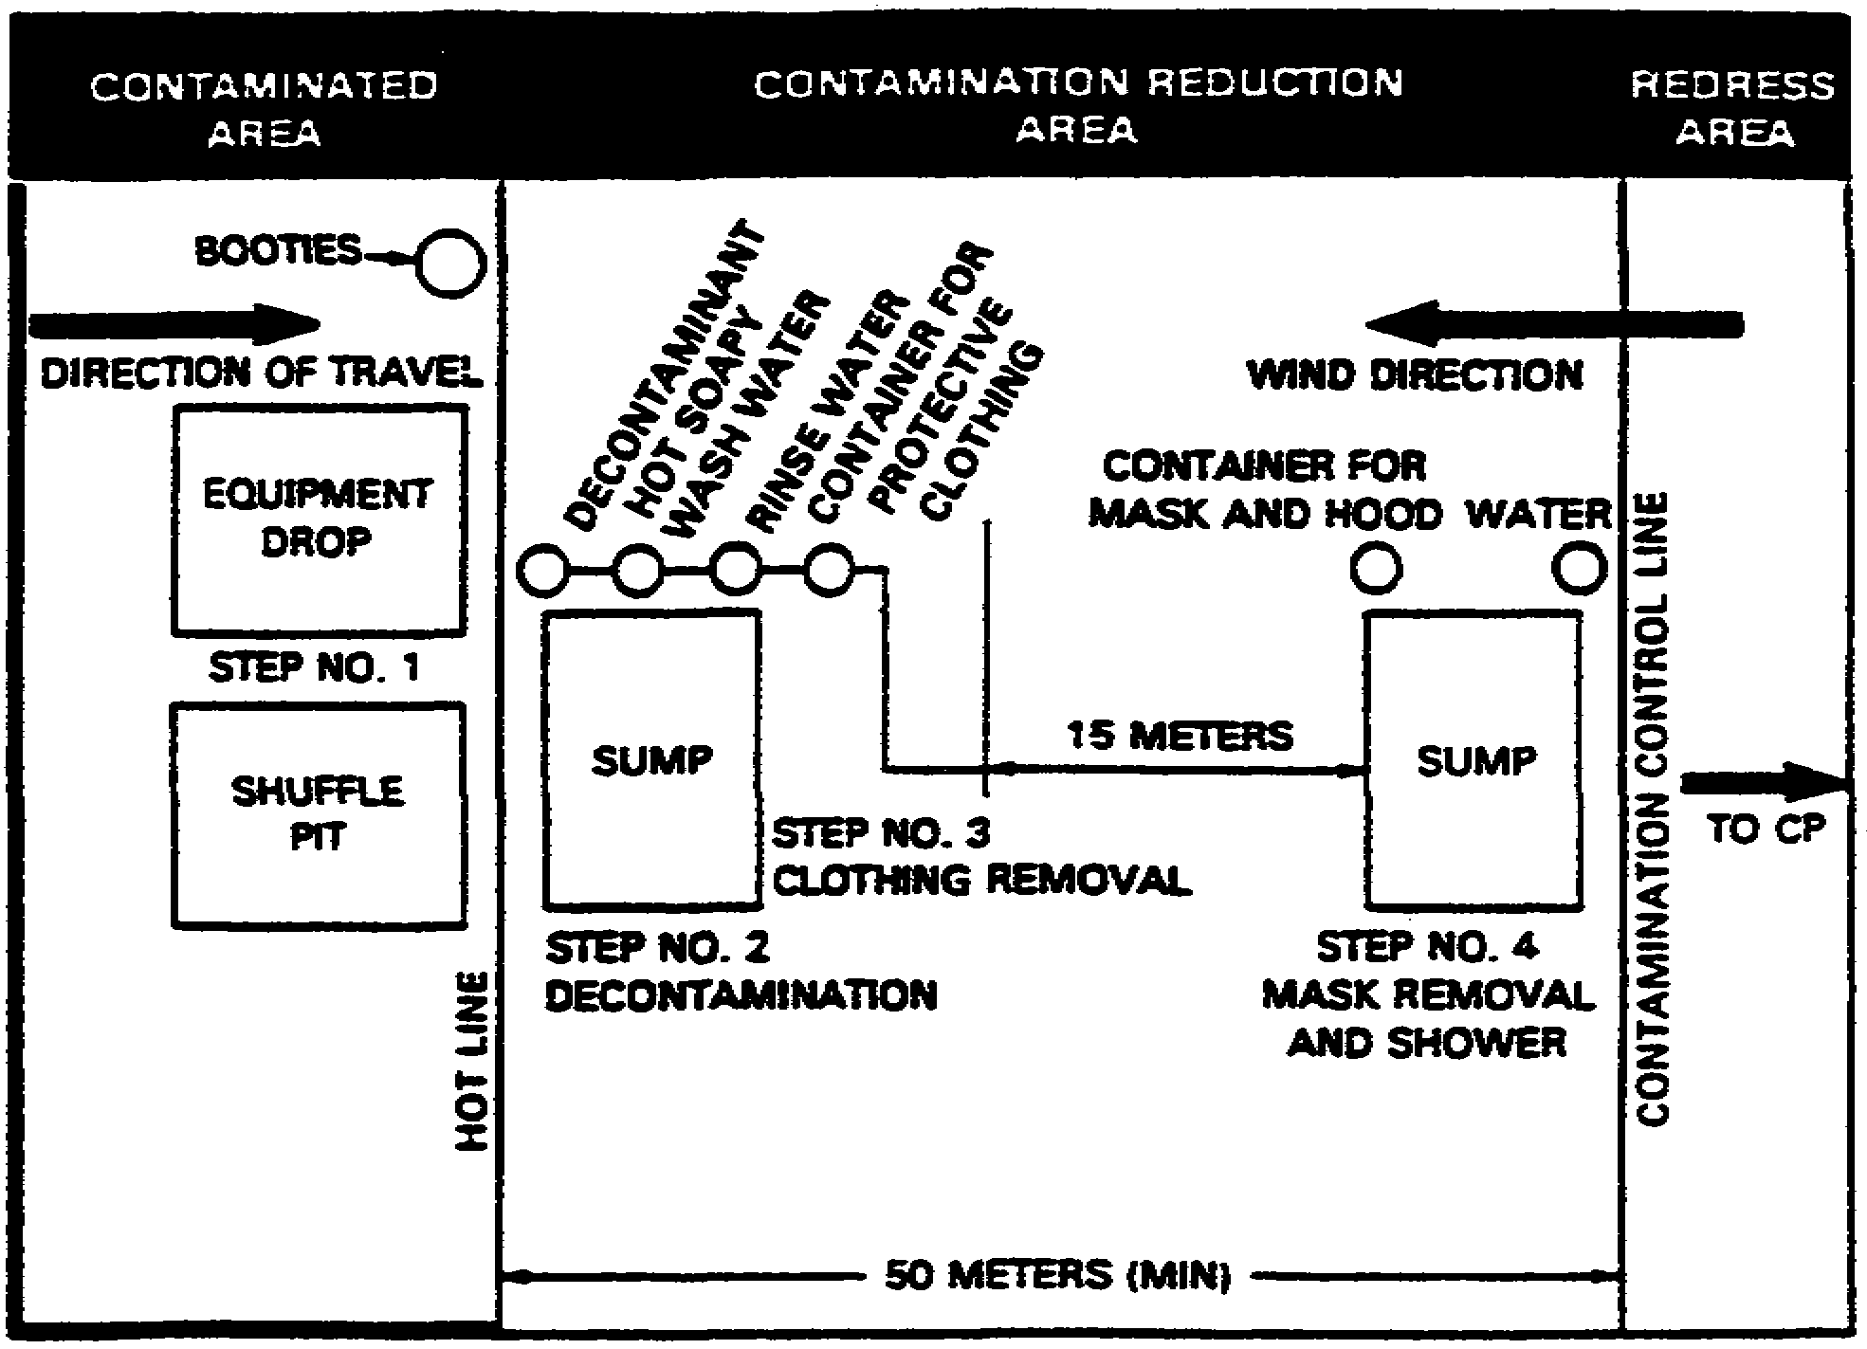

Figure 2 EOD Personnel Decontamination Station

36

Lesson #2 Self-Test

Circle the letter of each correct answer.

1. Currently, all commercial chemical incidents will be handled by

a. EOD units
b. federal government agencies
c. local or state authorities

2. The lowest agency that can request assistance from the EOD is

a. the governor's office
b. the federal EPA HQ
c. local or state authorities

3. "Specific authority for disposal of toxic agents/munitions must be obtained before conducting disposal operations." Does this restriction apply to emergency situations?

a. Yes--but the authority does not have to be written
b. Yes--specific authority in writing is always necessary
c. No

4. The least environmentally harmful method of disposal will be determined by

a. EPA
b. EOD
c. local authorities

5. Which of these areas would make the best disposal area?

a. a low lying valley
b. a forest
c. high, open terrain

6. A minimum radius of _______ meters should be clear of combustibles.

a. 60
b. 30
c. 100

37

7. If you are going to use burning as a method of disposal, which of these should not be spread over the combustible material?

a. motor oil

b. thickened flame fuel

c. gasoline

d. diesel fuel

8. After a burning operation, you should let the pit cool for at least _______ hours before checking for residual contamination, explosives, and other hazardous items.

a. 2

b. 12

c. 24

9. True or False: During peacetime, nerve agents should be disposed of by open pit burning.

10. To ensure that munitions have been destroyed by a successful closed pit burning operation

a. watch the "telltale” device burn and make sure there is no smoke leaving the pit.

b. wait at least one hour and then open the pit to make sure everything has burned.

c. wait for the smoke to come up and then douse with an 80% solution of calcium hypochlorite.

11. Venting should not be used for

a. chemicals with a high volatility

b. CG, CK and AC

c. nerve agents

12. Biological agents can probably be destroyed in a short period of time by

a. burning

b. boiling

c. venting

38

13. Disposal at sea

a. should be used for nerve agents, since they are too volatile for other methods

b. must be at least 100 miles out and must be approved by the Coast Guard

c. requires approval by Congress

14. Land burial

a. must be approved by Congress

b. is the best way to dispose of most hazardous materials

15. In a PDS, the line separating the contaminated area from the contamination reduction area is called the

a. hot line

b. contamination control line

c. clean line

16. The ___________ separates the contamination reduction area from the clean area.

a. hot line

b. contamination control line

c. clean line

39

Lesson #2 Self-Test Answers

1. c
If you got this wrong, go back to page 15 and review.

2. b
If you got this wrong, go back to page 15 and review.

3. c
If you got this wrong, go back to page 15 and review.

4. a
If you got this wrong, go back to page 16 and review.

5. c
If you got this wrong, go back to page 17 and review.

6. a
If you got this wrong, go back to page 17 and review.

7. c
If you got this wrong, go back to page 20 and review.

8. b
If you got this wrong, go back to page 20 and review.

9. False
If you got this wrong, go back to page 21 and review.

10. a
If you got this wrong, go back to page 21 and review.

11. c
If you got this wrong, go back to page 22 and review.

12. b
If you got this wrong, go back to page 24 and review.

13. c
If you got this wrong, go back to page 24 and review.

14. a
If you got this wrong, go back to page 24 and review.

15. a
If you got this wrong, go back to page 25 and review.

16. b
If you got this wrong, go back to page 26 and review.

40

LESSON 3

OBJECTIVE: Direct EOD Support of Range Clearance Operations

TASK: Upon completion of this lesson you will be able to direct EOD support of range clearance operations.

CONDITIONS: Given this booklet and a pencil.

STANDARDS: Correctly answer all the questions on the Lesson #3 self-test. You must get 100% on the lesson self-test before you take the subcourse examination.

REFERENCES: TM 9-1300-206
FM 9-15

41

LESSON 3

DIRECT EOD SUPPORT OF RANGE CLEARANCE OPERATIONS

Introduction

In this lesson you learn how to direct EOD support of range clearance operations. There are 2 enabling objectives in this lesson. You must know how to do both of these objectives.

OBJECTIVE CLEAR RANGE AND IMPACT AREAS
1

OBJECTIVE PERFORM AREA CLEARANCE OPERATIONS (ASP CLEANUP)
2

42

OBJECTIVE CLEAR RANGE AND IMPACT AREAS
1

1. As the EOD supervisor of a detachment, you will plan and conduct range operations. The type of operation will dictate how the unit will take part. Installation range clearances will normally be handled by Range Control with EOD supporting their operation. An ASP clean-up operation would normally be planned and conducted by EOD personnel with additional personnel supporting your operation. We will look at the different types of range operations and the different areas that must be considered when planning and conducting the operation.

2. Clearance of ranges and impact areas.

a. Items to consider in planning.

1. Determine and define areas to be cleared.

(a) Perform map, aerial, and ground reconnaissance.

(b) Prepare maps showing the areas for:

(1) Staking parties (grids)

(2) Collection points

(3) Command post location

(4) Billeting and messing facilities

(5) Explosive storage

2. Research range records to determine quantity and type of ordnance in area.

3. Determine requirements in the following areas and requisition as required.

(a) Personnel will be required to perform the following operations:

(1) Medical support

(2) Staking parties

(3) Vehicle drivers

43

(4) Heavy equipment operators

(5) EOD support

(6) Fire protection

(7) Other functions as needed by local SOPs.

(b) Demolition materials

(c) Vehicles to include:

(1) Trucks for staking parties and EOD operations

(2) Ambulances

(3) Heavy equipment

(d) Miscellaneous supplies and equipment

(1) Fuel for vehicles

(2) Replacement tires

(3) Communications equipment

(4) Personal equipment

(5) Demolition set

4. Develop final plans

5. Prepare and conduct safety and ordnance recognition classes for all personnel.

6. Arrange for burning of range if required for visibility.

7. Coordinate operation with all supporting elements.

b. Clearance Procedures

1. Staking Parties

(a) An NCO is in charge of every 10 stakers. Stakers will be in line formation. The unit must stay together.

(b) EOD personnel walk behind stakers to inspect ordnance.

44

(c) Action to be taken on finding ordnance:

(1) Stop line.

(2) EOD inspects ordnance. If it is free of explosive, place it on scrap truck. If it is too hazardous to move, place a stake for later destruction.

(d) When required, scrap truck takes scrap to collection point.

(e) At completion of staking operation, the section leader marks boundaries of the area staked by the section.

(f) At the end of the day, all non-EOD personnel leave the range. The section leader accounts for all personnel.

(g) EOD remains to dispose of all staked ordnance.

2. EOD personnel at Collection Point.

(a) Inspect all incoming scrap for explosive components.

(b) Remove all explosive components and take them to the range for disposal.

45

OBJECTIVE PERFORM AREA CLEARANCE OPERATIONS (ASP CLEAN UP)
2

Area clearance operations (ASP clean up).

1. General priorities - Each operation will differ, but the following steps apply in most cases.

a. Establish a command post. Communications should be set up between all operating areas.

b. Provide for medical care and evacuation. Medical personnel and ambulances must be present in each area of operation. Helicopter landing areas must be set up because land vehicles may not be able to get through areas where there are metal fragments.

c. Clear roadways first so traffic can resume.

d. Clear populated areas.

e. Clear revetments and other areas in the ASP containing heavy amounts of damaged ammunition.

f. Start disposal operations. Disposal operations should begin ASAP to prevent large quantities of hazardous ammunition from building up in exposed holding areas.

2. Personnel

a. As a rule, the size of ASP cleanup and disposal operations makes it necessary for EOD personnel to be aided by others who can be trained at the site to perform certain operations under the supervision of EOD technicians. Ammunition technicians, because of their knowledge of ammunition and explosives, are the most easily trained and need the least supervision. Other personnel can be used for the cleanup of non-explosive scrap after they have received training in recognizing hazardous ammunition.

b. Communications and medical personnel, heavy equipment operators, and truck drivers can also aid operations personnel.

c. Team composition

(1) For cleanup operations, a team consisting of one EOD technician and six ammunition technicians is considered best, with the ratio never exceeding one to ten. When required, teams may be combined to form passing lines.

(2) For disposal operations, a team of three EOD technicians to eight ammunition technicians is best.

46

3. Training

a. Ammunition technicians who will be working in cleanup or disposal operations should be given intensive training on each item of ordnance that can be found in the area. Emphasis should be placed on the hazards inherent in each item. Samples of each item--both damaged and perfect--should be used for teaching munition identification.

b. Newly arrived EOD personnel should be given refresher training on each item of ordnance they will encounter. All other personnel should be familiarized with all ordnance so they can identify hazardous items.

c. Safety must be stressed and lectures repeated often--at least once a day. ASP cleanup is hard, dulling work and it is easy to develop careless habits.

4. Equipment - Since the amount of equipment needed depends on the size of the operation, it is impossible to decide exact requirements at first. The following equipment has been used in other operations:

a. Vehicles. Since the cab of the cargo truck is protected by sand-filled, 55-gallon drums, and the bed is covered with sandbags, the 5-ton cargo truck is more suitable than the 2 1/2-ton. Track laying cargo vehicles, instead of rubber-tired vehicles, should be used because extensive tire damage, especially in the demolition area, means a constant resupply of tires. A dump truck is required for carrying scrap. The following vehicles are required:

(1) Cargo truck, 5-ton or 2 1/2-ton, one per cleanup team

(2) Dump truck, 5-ton, one

(3) Fire truck, one for each operating area

(4) Ambulance, one for each operating area

(5) Command vehicle with two-way radio, one

b. Heavy equipment. The following items of heavy equipment are required. The number of each depends on the number and size of the operational areas.

(1) Bulldozer

(2) Front-end loader

(3) Forklift

(4) Mobile crane

(5) Road grader

(6) Road sweeper

47

(7) Mobile magnet

c. Miscellaneous items. The following items are required:

(1) Water containers

(2) 55-gallon drums

(3) Propellant charge canister, metal (155-mm, 175-mm, 8-inch)

(4) Gloves

(5) Common hand tools

(6) Banding cutters

(7) Shovels

(8) Small wooden boxes

(9) Tape

(10) Handling slings

(11) Lifting bars

(12) Wooden or metal stakes

(13) Minefield marking tape

(14) Radios for operative areas

(15) Flak vests

(16) Safety glasses or face shields

5. Explosives

a. Bulk explosives. In a one disposal operation, about two pallets (1000 rounds) of plastic explosives were used each day to destroy munitions at a rate of 50 tons per day.

b. When large quantities of explosives are required in a single shot, bombs should be used to conserve bulk explosive. Sheet explosive can be used to destroy small items.

48

6. Procedures

a. General

(1) The size of an ASP cleanup and disposal operation makes it impractical to follow the procedure set down for each munition. A blow-in-place procedure or any remote attack that could result in a detonation might start a sympathetic detonation which would make the problem worse. The most practical way to clean up an ASP disaster area is to remove all munitions to a disposal area.

(2) To reduce the hazards inherent in the gathering of large quantities of unprotected ammunition, disposal operations should be done at the same time as cleanup operations. There should be a constant flow of ordnance from the ASP to the disposal area.

(3) As a rule, ordnance is handled three times before it is destroyed. First, it is moved from random areas and stacked at the roadside. Then it is lifted and stacked on the transport vehicle. At the disposal area, it is unloaded and stacked for disposal.

(4) If cleanup and disposal are conducted in a war zone, perimeter guards must be stationed around the ASP and disposal area. You must maintain sweeping operations and other surveillance to guard against hostile troops who could mine or boobytrap the areas at night.

b. Cleanup procedures

(1) All ordnance and scrap must be removed from the road before starting operations in the ASP. After the roads have been cleared of ordnance and large pieces of scrap metal, they should be swept by a mobile magnet and scraped by a bulldozer; tire damage may occur. You can stand scrap ordnance on end to indicate cleared areas.

(2) Small sensitive items

(a) Small clustered or dispenser-launched grenades or bombs will usually be armed when found separated from the cluster adapter or dispenser. In this condition they are extremely sensitive and cannot be safely transported in vehicles. You should wear a flak vest and eye protection, such as safety glasses or a face shield when working with these items. The following procedures are recommended:

(b) When found in small numbers, hand carry these items to a nearby disposal area within the ASP. Do not drop one of these items; carry no more than two munitions (one in each hand) at one time. They should be carefully laid on the ground in the disposal area and marked for alternate destruction.

49

(c) When found in large numbers, carry these items in small boxes which have a layer of sand in the bottom. Each layer of munitions should be covered by sand to prevent movement. No more than two layers of munitions should be placed in one box. These boxes should be placed in the disposal area for later disposal by detonation. They should be marked to show they contain armed munitions. Do not remove the items from the boxes for disposal.

(3) Projectiles, Mortar Rounds, Etc.

(a) Small projectiles, mortar rounds, and other munitions of similar size should be stacked by the roadside for later pickup and transport to the disposal area. A passing line is the safest and most effective way of moving ordnance from heavy concentration areas to the road. The following procedure is recommended:

(b) Mark off the section to be cleared in a checkerboard. Use minefield marking tape to outline the boundaries.

(c) Form a passing line along the width of the marked area, and move the line along the area, passing ammunition to the roadway(s). Usually this line has ammunition technicians alternations with EOD technicians who act in a supervisory capacity. When necessary, untrained personnel may be used if the passing line is properly supervised.

(d) One or more EOD technicians should move ahead of the passing line to identify, and mark for later disposal any ordnance that is too dangerous to be moved. Ordnance that can be moved is passed down the line to the end man, who stacks it at the collection point.

(4) Large projectiles. If large projectiles (155-mm, 175-mm, 8-inch) are in an area that cannot be reached by mechanized equipment and they have lifting eyes, they can be moved with steel lifting bars fitted with a hook.

(5) Bombs and other heavy ordnance. Heavy ordnance can be moved by slings fitted to mechanized cranes. Refer to BODB/TM/TO 60A-1-1-5.

(6) White Phosphorus (WP) Munitions. Operations on WP munitions should be left until last to allow as much burning out as possible. Leaking WP munitions can ignite spontaneously, and possibly initiate the burster. This is most likely to occur during hot weather or when the munition is disturbed. The following general principles apply to clearing WP munitions from an area.

50

(a) When possible, conduct all operations in cool weather or during the cool part of the day. Wear gloves when working with WP munitions.

(b) Place all leaking munitions in water-filled, 55-gallon drums. If only a few "leakers" are found, individual munitions can be placed in propellant charge canisters or any similar container that can be filled with water and sealed. Keep the munitions under water during transport to the disposal area. Lifting the drums aboard truck will be easier if you have four holes around the top of each drum for sling tools.

NOTE: WP Munitions known to be in good condition can be transported dry; however, WP munitions should not be mixed with other munitions either in stacks or during transport.

(c) Test an apparently burned out WP munition by putting a welding rod or similar probe into the open end of the munition. If this produces smoke, WP is present.

(7) Vehicle Preparation and Loading

(a) Cover the bed of a cargo truck with sandbags and protect the cab with sand-filled 55-gallon drums. Sandbags may be used as dunnage to support the munitions and prevent movement during transport.

(b) Carry a 55-gallon, water-filled drum on any truck that is transporting WP munitions so any leaking rounds discovered in transit can be submerged.

c. Disposal Procedures

(1) Either of two disposal methods can be used: sea dumps (when authorized) or detonation. The method used depends on the facilities available and the condition of the ordnance. Ordnance in relatively good condition can be dumped at sea (when authorized). This method can be used for photoflash and illuminating munitions which present a special problem in demolition. Ordnance in a hazardous condition, such as items with the explosives partially burned or melted, should be detonated. Rocket pods and similar items should not be dumped at sea since they may float.

(2) When large quantities of munitions are being destroyed, add bombs and large projectiles to the bulk explosives. Refer to NAVORD OP 5 Volume 1, TM 9-1300-206, or TM 60A-1-42 for general information on destruction of ammunition and explosives.

(3) Small sensitive items. Wear a flak vest and eye protection, such as safety glasses or a face shield, when working with small sensitive items. Scrape the area with an armor-plated bulldozer following disposal of small items.

51

(4) Individual Items. The disposal procedure for these items is:

(a) Place individual munitions on the ground in a rectangular pattern. There is no limit to the length of this pattern; but it should be narrow enough so you can position the explosive without having to lean over the munitions.

(b) Lay the explosive in strips on top of the items. Sheet explosive is best for this purpose. If not available, plastic explosive sliced into sheets will do. Prime the explosive at each end or at each corner. Single-point priming may scatter the munitions. Detonate remotely.

(5) Rocket Pods and CBU Dispensers. Rocket pods and dispensers need large quantities of explosives to ensure destruction and to prevent scattering of the small component munitions. Interspersing these items with 500-pound bombs has been found to give enough explosive for complete destruction. The items are laid out (bomb, dispenser, bomb, dispenser, etc.) with a row of bombs on the top. The bombs are primed alternately nose and tail, with plastic explosives in the nose or tail fuze well and detonating cord leads. The leads to the nose and tail fuze wells are attached to equal lengths of detonating cord initiated by a non-electric cap.

(6) Boxed Items. Small munitions brought to the disposal area in boxes should stay in the boxes. Detonate a layer of plastic explosive blocks placed on top of the box and primed at two opposite corners.

(7) Projectiles. Projectiles, set up for disposal, should be stacked approximately 2-feet high. The projectiles in the best condition should be placed on top and detonated with plastic explosive blocks laid end-to-end along the entire length of the stack.

(8) WP munitions

(a) Leaking WP munitions will arrive at the disposal area in water-filled, 55-gallon drums, or in water-filled, metal, propellant charge canisters or similar containers. Undamaged munitions will not be stored or shipped in containers.

(b) Undamaged WP Munitions. When WP and high-explosive (HE) ammunition is to be disposed of in the same stack, the ratio of HE to WP should be a minimum of two HE munitions to one WP munition. The stack should not be over 2 feet in height and should be constructed of alternate HE and WP layers, with an HE layer on the bottom and the top of the stack. Detonate the stack with blocks of plastic explosive laid end-to-end along the entire length of the stack.

52

(c) When only undamaged WP munitions are to be destroyed, they should not be stacked. Place the munitions in a single layer and detonate with blocks of plastic explosive laid end-to-end along the entire length of the layer. To ensure detonation, the fuze wells of large projectiles (155-mm) should be primed with plastic explosive.

(d) Leaking WP Munitions. Keep leaking WP munitions in their water-filled containers for disposal. Those in propellant charge canisters or other small containers may be interspersed with HE ammunition.

(e) To ensure complete destruction, a water-filled drum containing WP munitions should be placed in the center of a four-sided stack of HE munitions.

NOTE: If the barrel is full or nearly full of WP munitions, a primed haversack or two of plastic explosive, or equivalent, should be placed on top of the WP.

53

This page intentionally left blank

54

Practice Exercise #3

You have been asked by the Commander of III Corps at Fort Sill, OK to perform an area clearance operation. For numbers 1-4, state whether each sentence is True (T) or False (F).

___1. Helicopter landing areas may be set up only if you think they are necessary.

___2. Roadways should be cleared first so traffic can resume.

___3. Population areas do not need to be cleared for this type of operation.

___4. Disposal operations should be started last so clearance operations can be conducted effectively.

5. You will need personnel to assist EOD personnel. Who are the most easily trained for this purpose?

6. How much training should be given to ammunition technicians who will be working in cleanup or disposal operations?

7. Is it necessary to train newly arrived EOD personnel?

8. You require a large quantity of explosives in a single shot. What should you use?

9. What is most practical way to clean up an ASP disaster area?

55

Answers to Practice Exercise #3

1. F

2. T

3. F

4. F

5. ammunition technicians

6. intensive training on each item of ordnance that can be found in the area

7. Newly arrived EOD personnel should be given refresher training on each item of ordnance they will encounter.

8. A bomb should be used to conserve bulk explosive.

9. Remove all munitions to a disposal area.

56

Lesson #3 Self-Test

Circle the letter of each correct answer.

1. During a range clearance operation, ordnance free of explosive is

a. left in place

b. placed on a scrap truck

c. destroyed at the site

2. At the end of the day, after all non-EOD personnel leave the range, EOD personnel

a. remain to dispose of all staked ordnance

b. re-inspect the area within the designated boundaries

c. vacate the inspected area and report to the collection point

3. Medical personnel

a. must be on call and able to respond within 5 minutes

b. must be present in each area of operation

c. are not needed unless WP is present

4. The personnel most easily trained as aids for disposal operations are

a. artillery NCO's

b. MOS 12

c. ammunition technicians

5. Which of these statements is true?

a. It is better to use a 5-ton cargo truck for clearance operations than a 2 1/2-ton.

b. Rubber-tired vehicles are better to use than track laying cargo vehicles.

c. A dump truck is not required but should be used to carry scrap and excess equipment.

6. True or False. You must follow the disposal procedures set down for each munition during a cleanup operation.

57

This page intentionally left blank

58
7. True or False. The best way to dispose of ordnance in a cleanup operation is a blow-in-place procedure.

8. True or False. The most practical way to clean up an ASP disaster area is to remove all munitions to a disposal area.

9. Disposal operations should be done

a. at the same time as cleanup operations

b. immediately after the cleanup operation

c. within 8 hours of the cleanup operation

10. Small clustered or dispenser-launched grenades or bombs should be considered armed. The procedure recommended for these items is:

a. Detonate them where they are found

b. Carry them by hand or in a small marked box and detonate them at the disposal area.

c. Put them in a box to carry them to the disposal area. Then remove them one at a time for detonation.

11. Operations on white phosphorous (WP) munitions should be

a. done right away--as soon as they are found

b. done with all the other munitions

c. left until last

12. WP munitions

a. can never be transported dry

b. can be mixed with other munitions

c. should be handled during the cool part of the day

59

Lesson #3 Self-Test Answers

1. b
If you got this wrong, go back to page 45 and review.

2. a
If you got this wrong, go back to page 45 and review.

3. b
If you got this wrong, go back to page 46 and review.

4. c
If you got this wrong, go back to page 46 and review.

5. a
If you got this wrong, go back to page 47 and review.

6. False
If you got this wrong, go back to page 49 and review.

7. False
If you got this wrong, go back to page 49 and review.

8. True
If you got this wrong, go back to page 49 and review.

9. a
If you got this wrong, go back to page 49 and review.

10. b
If you got this wrong, go back to page 49 and review.

11. c
If you got this wrong, go back to page 50 and review.

12. c
If you got this wrong, go back to page 51 and review.

60

LESSON 4

OBJECTIVE: Direct/Advise on Search Operations for IED

TASK: Upon completion of this lesson you will be able to direct/advise on search operations for IED

CONDITIONS: Given this booklet and a pencil

STANDARDS: Correctly answer all the questions on the Lesson #4 self-test. You must get 100% on the lesson self-test before you take the subcourse examination.

REFERENCES: TC 19-5
AR 75-15
TM 60L-1-1-1
TEC Lesson 431-093-7379A

61

LESSON 4

DIRECT/ADVISE ON SEARCH OPERATIONS FOR
IMPROVISED EXPLOSIVE DEVICES (IED)

Introduction

In this lesson you will learn how to direct/advise on search operations for Improvised Explosive Devices (IED). There are 5 enabling objectives in this lesson. You must know how to do all 5 of these objectives.

OBJECTIVE PLAN SEARCH
1

OBJECTIVE PREPARE TO SEARCH
2

OBJECTIVE KNOW SEARCH TECHNIQUES
3

OBJECTIVE KNOW HOW TO SEARCH AN AUTOMOBILE
4

OBJECTIVE KNOW WHAT TO DO WHEN A BOMB IS FOUND
5

The guidance for EOD in this area changes very quickly. We will discuss the very general guidance concerning these areas. Your control detachments and/or FORSCOM EOD section will apply this guidance to specific situations.

Currently, EOD units will not search a target area for an IED. EOD units are too small and do not have the resources available to conduct the search. Normally EOD units will put a team on standby when notified of a bomb threat. See AR 75-15 and FORSCOM Suppl 1 to AR 75-15.

62

OBJECTIVE PLAN A SEARCH OPERATION FOR IED
1

1. Find person(s) who has requested the search or represents the agency requesting the search.

2. Get all available data on any bomb threats.

a. Was the threat received?

b. When was the threat received?

c. When is the bomb supposed to detonate?

d. Was a particular area or person threatened?

e. How was the threat received?

f. What were the exact words of the threat?

g. Has any responsibility for the threat been claimed or established?

h. What is the history of bomb threats at this facility?

3. Get all available data on the facility's bomb threat plan.

a. When planning has been done:

(1) Who is designated in the plan as being responsible for:

(a) Authority to evacuate.

(b) Searching the facility.

(2) Evaluate any available search plans to determine if they provide the following data:

(a) Floor plan of the facility.

(b) Location of key areas of the facility, for example:

Computer room

Elevator control rooms

Telephone switchboard rooms

Receiving area for mail and other material

63

Records holding area

Executive offices

(c) Points where you can get to utilities:

Major water and sewage pipes

Major electric lines, switchboxes, etc.

(d) Location of any hazards in the facility:

Gas lines and gas containers

Other flammable material

(e) Areas that are open to the public

(f) Areas that are normally locked

(g) Sufficient details of rooms to determine what items belong in them.

(h) The entry point and distribution route for mail, supplies, and other incoming material.

(i) The location of trash containers, when they are emptied, and where the trash is kept until it is hauled away from the facility.

(3) Attempt to find persons who can provide data not included in the plans.

b. Attempt to find people who can provide the data indicated in 3a(2) above, when no prior planning data is available. Security and maintenance personnel are the most likely sources.

4. Determine the type and extent of search required:

a. Type: Overt--No attempt is made to conceal the search of the facility.

b. Extent:

(1) Search of entire facility:

(a) Is time consuming.

(b) Requires cooperation of occupants since a search team is not likely to know what belongs in each area.

64

(2) Public access areas only.

(3) A designated area only, such as threatened area or area to be occupied by VIP.

(4) Assign available personnel and equipment to perform the search determined in performance measure 4 above:

(a) Assign people familiar with the area to work with the searchers in that area.

(b) Assign each search team a definite area of responsibility.

(c) Tell the searchers how to mark the areas they search.

(d) Tell the searcher what measures are to be taken to secure the area after the search so they can coordinate with security.

5. Monitor the conduct of the search to ensure it is done correctly.

65

OBJECTIVE PREPARE TO SEARCH
2

1. In the past decade, militant groups, criminal elements, and scores of others have manufactured and used explosives and incendiary devices. Bomb-incident data reflect that bomb incidents pose a continuing and ever-present threat to civilian and military personnel, property, and operations. Bombings in the United States have resulted in lives lost, people injured, and millions of dollars of property damaged. Bombing incidents have not decreased significantly in the past few years. They will probably continue to plague military and civil facilities and organizations.

2. There is a need for practical knowledge to cope with these violent activities. This need has been partially met by various law enforcement agencies. Yet, it must be remembered that the protection of life and property is a responsibility that cannot be delegated solely to law enforcement.

3. Search:

a. Search Teams. There are three groups of individuals who may serve as members of the search teams. They are building supervisors, building occupants, and special search teams. Of the three, the specially trained search teams are the most effective, especially when combined with a brief search by occupants before they are evacuated.

b. Who searches? Except for the most unusual circumstances, EOD and military police will NOT be used to search for reported explosive devices in barracks, community areas, buildings, and offices. Rather, such searches will be conducted by designated individuals familiar with the area and its contents. If an unusual item is found, EOD is to neutralize and evacuate the device for disposal. Military police are to be employed around the threatened area to control traffic and provide other regulatory services. Therefore, in the Army, the occupants of the building will perform the search along with designated search teams.

c. What will be searched? Occupants will search their own work areas and rooms. Search teams should be assigned to search public areas, rest rooms, and closets. Keys should be available to searchers so every area can be searched. A complete search must be made, since one or more bombs could exist.

d. When is the search terminated? After the entire facility has been searched. Remember, the discovery of one device should not necessarily stop the search; there could be more than one bomb. This was a tactic used in Saigon.

66

OBJECTIVE USE PROPER SEARCH TECHNIQUES
3

1. There are many factors to consider before ordering a search if you are the commander or Bomb Scene Officer.

a. Will the search be overt or covert?

b. Will the search be conducted before evacuation, after evacuation, or without evacuation?

c. Will the search be conducted by supervisors, occupants, or a special team?

d. How much of the building will be searched?

e. A detailed search of even a medium-size building can take from 12 to 24 hours, and moving the furniture and equipment around will cause considerable confusion and inconvenience to the occupants. Since many bombs are activated by some type of watch or clock mechanism, by the time the bomb has been set and you receive the warning there is much less than 12 hours of actual search time left.

2. The extent of any search will be determined by the number of people available to search and the commander's evaluation of the threat. Remember, military police do not order searches, evacuation, or reentry into a building after an evacuation. These decisions are all made by the commander or building supervisor concerned.

3. The individual or group of individuals selected to conduct the search must be given special training in systematic search procedures and must be taught to recognize a bomb or explosive device (EOD will assist in this training). The key to a successful search is to be systematic. All searches must proceed in an orderly manner from the starting point throughout the area, with each room being marked or sealed after it has been searched.

4. Depending on their area of responsibility, search teams should be equipped with some of these items:

Standard and Phillip screwdrivers
Flashlight
Body Armor, such as flak vest
Crescent wrench
Hand mirror
Plastic ribbon, string, or crepe paper for marking searched area

67

5. Search Techniques - Outside

a. Common sense shows that the search proceeds from the outside to the inside, and from the bottom to the top. These principles have resulted from years of practical experience and reduce the risk of injury to both the searchers and the occupants.

b. All phases of the search may be conducted at the same time if a large, trained search team is available. If the search teams are to be divided, the following breakdown of team members has been found to be effective:

Outside search - 25%
Public areas - 25%
Detailed room search - 50%

c. The smallest search unit should have two men because of the psychological and physical advantages. Two men will conduct a more thorough search and can work together when heavy furniture must be moved.

6. The search of the outside of a building is more important because this is the area most accessible to the bomber, especially when many buildings are closed. The outside search pattern begins at ground level and close attention must be given to:

Piles of leaves or refuse
Shrubbery
Entrances
Manholes
Trash cans
Parked vehicles (look, only;
suspect vehicles should be
searched by EOD personnel)

7. The search should be conducted outward to a distance of 25 to 50 feet from the building. After completing the ground-level search, return to the building and search window ledges, air-conditioning units, signs, building ornamentation, fire escapes, and the roof. After completing the outside search, members of this team may be added to the inside search team.

8. Search Techniques - Inside

a. Search of the inside will start with the basement and work toward the top floor. If a separate public-area search team is organized, use building custodial personnel on the team because they are most familiar with the areas to be searched; for example, reception rooms, lobbies, elevators, stairs, custodial closets, and rest rooms. As search teams move through the building, each area is marked as it is searched to avoid repeating the search by other teams. One method of showing a “search-completed” area is to tie a piece of string or crepe paper across the door openings.

68

b. When conducting a detailed room search:

(1) Move into the room, stand with eyes closed, and listen. Frequently, clockwork timing devices can be detected without special equipment.

(2) Divide the room into equal parts according to the number of objects to be searched, not the size of the room.

(3) The first sweep of the room includes a check of all objects from the floor to waist level. This sweep will take the most time and effort because it includes almost all items of furniture, underneath rugs, as well as items built into the wall.

(4) The second sweep, in the most cases, will include all items from waist to ceiling. Under some conditions, false ceiling spaces, heating ducts and indirect lighting fixtures may be left for a third sweep.

(5) The room search is ended only when the person in charge is satisfied that an adequate search has been made. Remember the searcher should never say, "There is no device." He should only say, "No device was found."

9. Summary. A systematic search for an IED can provide a very accurate search, when speed is of the utmost concern. You must find the device, before the device can be RSP'd, so planning and implementing a systematic search with trained people may very likely save a life and valuable equipment.

69

OBJECTIVE SEARCH AN AUTOMOBILE
4

1. Check area around automobile for:

a. Jack marks

b. Foot prints

c. Pieces of tape, string, or wire used to secure an IED

2. Prior to checking underside of vehicle you should:

a. Block all wheels to prevent rolling

b. Use adjustable jacks to prevent tilting

c. Areas to check under vehicle

1. Engine and transmission area

2. Exhaust system

3. Gas tank

4. Wheel wells

3. Wheel covers removed remotely

4. Check engine compartment

a. Prior to checking engine compartment you would:

(1) Disconnect the battery remotely

(2) Check engine compartment for signs of tampering

b. Areas to check in engine compartment

(1) Air filters

(2) Access panels

(3) Equipment mounted on firewalls

70

5. Areas to check in passenger compartment

a. Check doors and behind door panels

b. Under floor mats

c. Under dashboard (heater duct, air duct)

d. Ashtrays

e. Dome light

f. Headliner

g. Sunvisors

h. Glove compartment

6. Areas to check in truck:

a. Wheel well

b. Electric wiring

c. Tail light compartments

d. Gas tank filler pipe

71

OBJECTIVE KNOW WHAT TO DO WHEN A BOMB OR SUSPECTED BOMB IS FOUND
5

1. Action Required When a Bomb or Suspected Bomb is Found:

a. The search unit should not touch or handle any suspected incendiary device or bomb. The person in charge should contact the military police who will then notify the nearest military Explosive Ordnance Disposal (EOD) Detachment.

b. EOD personnel will attempt "render safe" procedures in accordance with AR 75-15, Responsibilities and Procedures for EOD.

c. In the case of an actual bombing, all personnel are warned not to tamper with the debris. It will be searched by government authorities for clues and all foreign evidence will be removed for scientific analysis.

72

Practice Exercise #4

You have been requested to assist in preparing an IED search program. Look at the following DF and sketch of the auditorium and answer the following questions:

1. Who searches:

2. Who does not search:

3. What will be searched in the auditorium:

4. When will the search be terminated:

5. Action required when a bomb or suspected bomb is found:

73

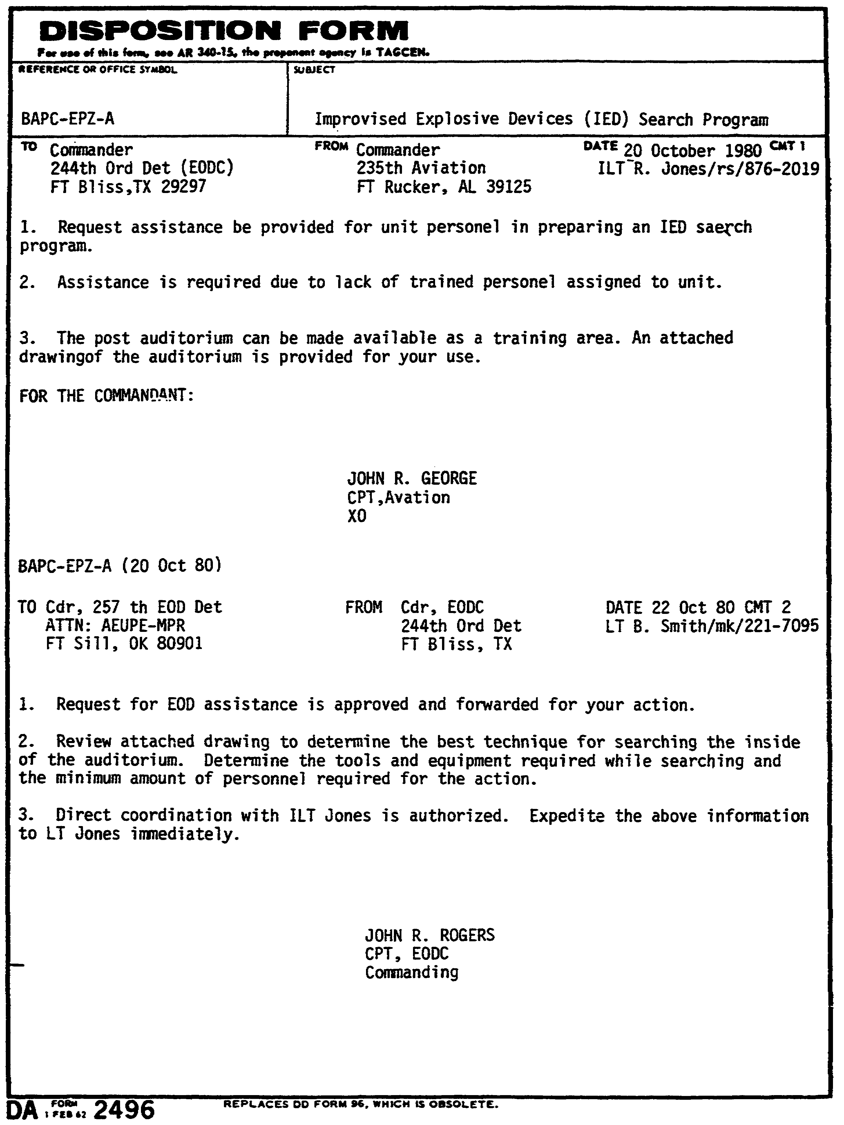

74

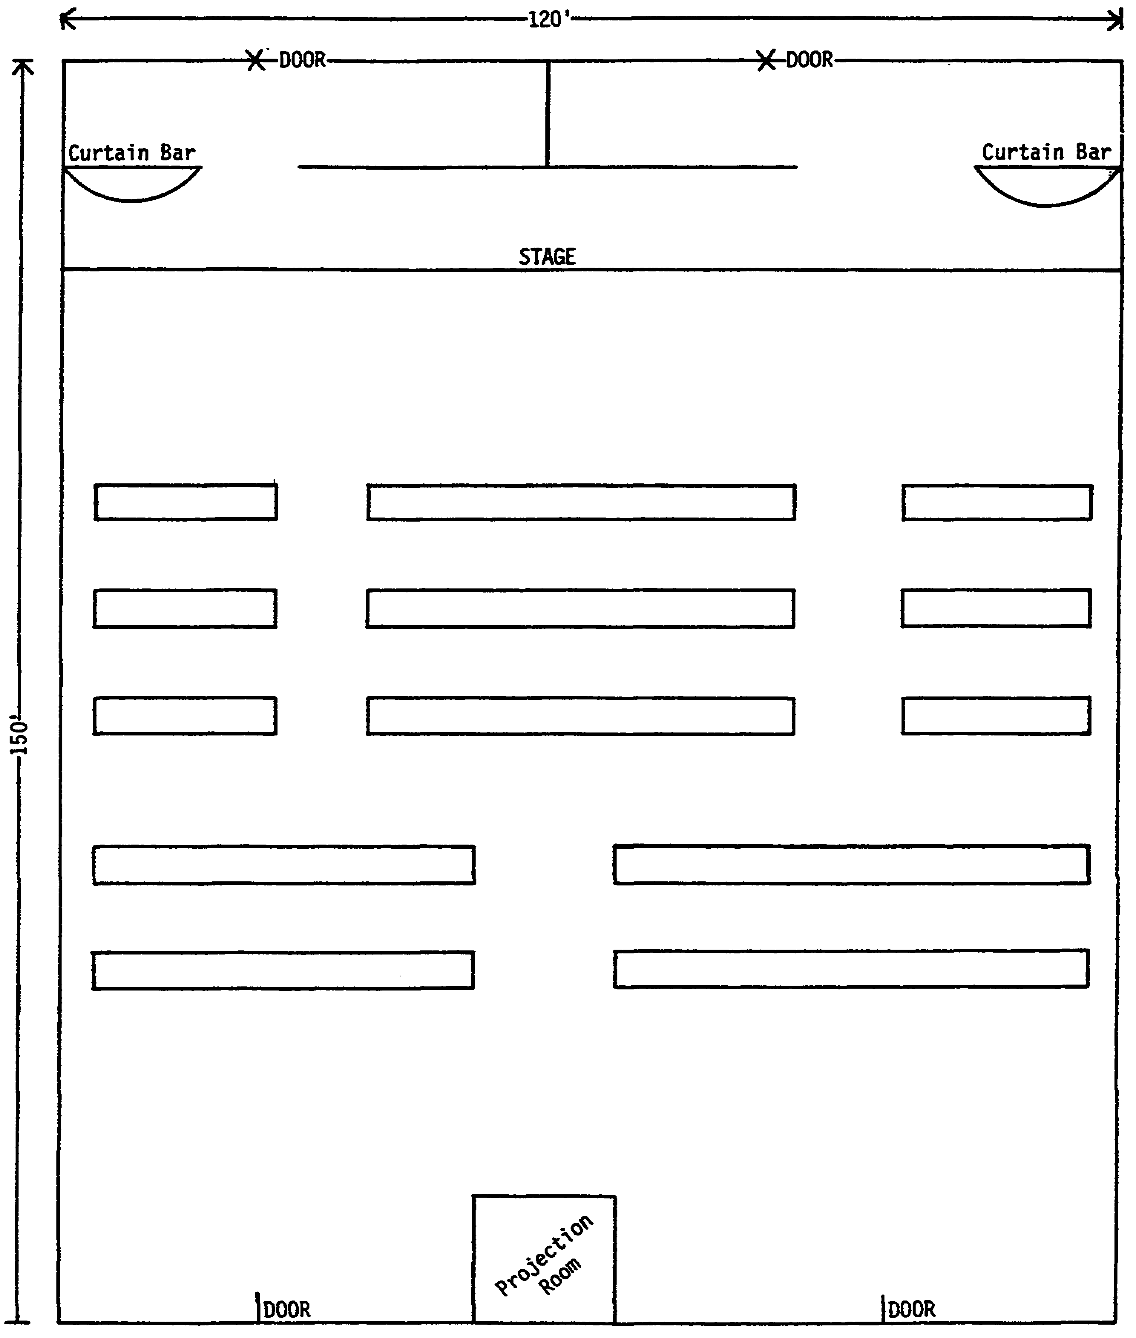

75

Answers to Practice Exercise #4

1. Who searches: Personnel who are familiar with building, designated individuals familiar with area and its contents.

2. Who does not search: EOD personnel and Military Police will not be required to search community areas, barracks and offices.

3. What will be searched in the auditorium: All common areas, to include seating area, bathrooms, and stage. All restricted areas to include projection room and offices.

4. When will the search be terminated: After entire area has been searched. You should not stop if one item has been discovered. There may be more.

5. Action required when a bomb or suspected bomb is found: Any bomb or suspected bomb should not be touched. Military Police will be notified, who in turn will notify the nearest EOD Detachment.

76

Lesson #4 Self-Test

Circle the letter of each correct answer.

1. Who searches for IED?

a. EOD

b. the occupants of the building

c. military police

2. What will be searched?

a. Occupants search their own areas.

b. Search teams search public areas.

c. Search teams search the whole area.

d. a & b

3. When is the search terminated?

a. when an IED has been found

b. when the entire facility has been searched

c. when the EOD officer is able to say "There is no bomb."

4. Who orders searches, evacuation or reentry?

a. military police

b. building supervisor

c. EOD NCOIC

5. The key to a successful search is:

a. to be as systematic as possible.

b. to involve as many searchers as possible.

c. to be as covert as possible.

77

6. The smallest search unit should have:

a. one man.

b. two men.

c. three or four men.

7. The area most accessible to a bomber is.

a. the outside of the building.

b. the hallway.

c. public conference rooms.

8. When searching an automobile:

a. disconnect battery and remove wheel covers remotely.

b. search only what is visible, do not remove panels, covers, etc.

c. do not lift the hood of the engine.

9. When a bomb is found:

a. EOD personnel attempt RSP.

b. the military police remove the bomb.

c. it is searched by government authorities.

79

Lesson #4 Self-Test Answers

1. b
If you got this wrong, go back to page 66 and review.

2. d
If you got this wrong, go back to page 66 and review.

3. b
If you got this wrong, go back to page 66 and review.

4. b
If you got this wrong, go back to page 67 and review.

5. a
If you got this wrong, go back to page 67 and review.

6. b
If you got this wrong, go back to page 68 and review.

7. a
If you got this wrong, go back to page 68 and review.

8. a
If you got this wrong, go back to page 70 and review.

9. a
If you got this wrong, go back to page 72 and review.

80

LESSON 5

OBJECTIVE: Identify Limitations on Authority of an NCO Serving as Acting Commander

TASK: Upon completion of this lesson you will be able to identify limitations on authority of an NCO serving as acting commander.

CONDITIONS: Given this booklet and a pencil.

STANDARDS: Correctly answer all the questions on the Lesson #5 self-test. You must get 100% on the lesson self-test before you take the subcourse examination

REFERENCES: AR 600-20
AR 37-103
AR 735-5
Article 15 of the Uniform Code of Military Justice

81

LESSON 5

IDENTIFY LIMITATIONS ON AUTHORITY OF A NON-COMMISSIONED
OFFICER SERVING AS ACTING COMMANDER

Introduction

In this lesson you learn how to identify limitations on authority of a Non-Commissioned Officer serving as Acting Commander. There are 4 enabling objectives in this lesson. You must know how to do all 4 of these objectives.

OBJECTIVE ASSUME ACTING COMMANDER DUTIES
1

OBJECTIVE ADMINISTER MILITARY JUSTICE
2

OBJECTIVE PAY MEMBERS OF THE DETACHMENT
3

OBJECTIVE DETERMINE AUTHORITY FOR AN NCO TO SERVE AS A PROPERTY BOOK
4 OFFICER

82

OBJECTIVE ASSUME ACTING COMMANDER DUTIES
1

1. As the senior NCO in the detachment you will be required to assume the duties of the commander when he is absent from the unit. This situation might be for an extended period of time when there is no EOD officer assigned.

2. Assumption of command:

a. An NCO can exercise temporary command under the following conditions:

(1) Absence of the commander and no other officers in the unit.

(2) Disability of the commander and no other officers in the unit.

(3) Death of the commander and no other officers in the unit.

b. In making out the DF for assumption of command, the order will cite AR 600-20, Para 3-4a, as the authority.

c. As a temporary commander you will not, except in urgent cases, change or cancel the standing orders of the permanent commander without authority from the next higher commander.

83

OBJECTIVE ADMINISTER MILITARY JUSTICE
2

A noncommissioned officer does not have the authority to impose nonjudicial punishment under Article 15 of the uniform code of military justice. However, the recommendations of NCOs can be used by unit commanders when administering Article 15 punishment.

2. As an enlisted commander of troops, the NCO plays a very important role in furthering the efficiency of the detachment. This includes preventing incidents which would require trials by courts-martial or the use of nonjudicial punishment.

3. The NCO can impose extra training on the troops, as long as the extra training is directly related to the offense, (such as making a soldier get up an hour earlier for one week, due to the offense of not getting up on time for work).

84

OBJECTIVE PAY MEMBERS OF THE DETACHMENT
3

1. Agent of the U.S. Government for paying of troops:

a. AR 37-103, para 15-51 defines class “A" agent officers as commissioned officers or warrant officers who are appointed for the purpose of making cash payments to the troops.

b. NCOs cannot be class "A" agent officers. If your troops need cash payments, you must make arrangements with your servicing finance center to provide a pay officer or send your troops to the finance center to be paid.

85

OBJECTIVE DETERMINE AUTHORITY FOR AN NCO TO SERVE AS A PROPERTY
4 BOOK OFFICER

1. The only people that normally can be accountable officers are:

a. Commissioned officers

b. Warrant officers

c. Qualified civilian employees

2. Accountability will not be transferred to enlisted persons, except to such NCOs as may be designated under exceptional circumstances by:

a. Head of a DA staff agency

b. Major commander

c. Major subordinate commander

3. The major subordinate commander can only designate an accountable officer when concerned in a case of a/an:

a. Ungarrisoned post: This is an army post which is still maintained by the Army but is not occupied by uniformed troops. It could be occupied by U.S. Government civilian employees as is Savanna Army Depot, IL.

b. Minor installations or activities which do not in themselves, by virtue of the requirement for a short period of time or small value of the account, justify an officer or civilian officer.

c. Activity in a remote locality.

d. Overseas areas.

4. All the information we've talked about up to now has been extracted from AR 735-5. Your EOD control center may delegate you, the senior NCO, accountable officer under AR 735-5, if you do not have an officer available.

86

Lesson #5 Self-Test

GENERAL SITUATION

You, the Senior NCO, have assumed the role of Acting Commander. As situations arise you must make the appropriate decisions pertaining to each situation.

SITUATION I

The following situation has developed: Several soldiers in your detachment receive their pay in cash. Decide whether you can act as a Class A Agent and pay them, or if you must make other arrangements. If other arrangements are to be made, decide what alternatives are available to you and list them.

SITUATION II

Despite repeated counseling, a member of your detachment has missed several formations due to not getting up on time in the morning. Decide whether you could impose non-judicial punishment under Article 15. If not, decide what alternatives are open to you.

SITUATION III

You are the senior supervisor assigned to the 241st Detachment. Your commander has been admitted to the hospital for approximately 14 days. Prepare a statement for assumption of command. Use today s date as the beginning date.

Additional Information: UIC 4BJ5A

87

Lesson #5 Self-Test Answers

SITUATION I

NCO's assuming command may not act as Class A Agents. Other arrangements must be made such as:

1. Sending troops to finance to be paid.

2. Making arrangements with finance to provide a Pay Officer.

If you got this wrong, go back to page 85 and review.

SITUATION II

A NCO acting as a Commander cannot impose non-judicial punishment. However, he can recommend Article 15 punishment or impose punishment related to the situation. In this situation he could have the individual get up earlier and make additional formations.

If you got this wrong, go back to page 84 and review.

SITUATION III

See DF on next page.

If you got this wrong, go back to page 83 and review.

88

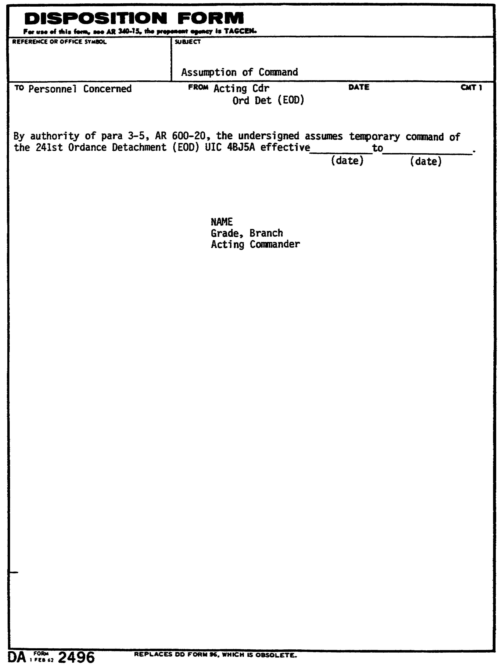

89

LESSON 6

OBJECTIVE: Plan a Unit Deployment

TASK: Upon completion of this lesson you will be able to plan a unit deployment.

CONDITIONS: Given this booklet and a pencil.

STANDARDS: Correctly answer all the questions on the Lesson #6 self-test. You must get 100% on the lesson self-test before you take the subcourse examination.

REFERENCES: FM 9-15
FM 55-10
FM 55-30
FM 101-10-1

90

LESSON 6

PLAN UNIT DEPLOYMENT

Introduction

In this lesson you will learn how to plan a unit deployment. There is one enabling objective in this lesson. You must know how to do this objective.

OBJECTIVE PLAN A UNIT DEPLOYMENT
1

91

OBJECTIVE PLAN A UNIT DEPLOYMENT
1

1. General

a. The number of moves an ordnance detachment is required to make will be governed by its assigned mission and the tactical situation.

b. The mobility of the ordnance detachment also has a bearing on any motor moves it may make. Moves should be made in one trip, when possible. This allows for rapid re-establishment in a new location and speedy resumption of mission operations.

c. The general area in which the unit will conduct future operations will be denoted in the order assigning it to that area. The commander later selects the specific area to be occupied by his unit within the general area.

2. Task Assignment

a. Steps. There are definite steps the commander of an ordnance detachment must take when he receives a new task assignment which involves moving the unit. These steps are taken to ensure that loss of time is kept to a minimum. The first step is to issue a warning order to key personnel for further dissemination to the rest of the detachment. The order accomplishes the following:

(1) Warns personnel of the impending move.

(2) Gives personnel time to start packing organizational and individual equipment for the move.

(3) Permits implementation of the loading plans and the securing of additional transportation, if necessary and if possible.

(4) Allows the current task assignment to be phased out.

b. Plans. The commander will plan for his reconnaissance and advance party.

(1) Reconnaissance. The commander will make a reconnaissance if the time between the receipt of the assignment and move allows. Normally, whatever other personnel he feels necessary will accompany him. If time is critical, reconnaissance and advance parties will go together. If the situation will permit use of a helicopter, the time required for the reconnaissance can be greatly reduced. On reconnaissance the commander should do the following:

92

(a) Select an area capable of being defended and yet suitable for technical operations. (Natural camouflage, road nets, and defensibility should be considered when selecting an area.)

(b) Select an alternate area to be used if the detachment's position becomes untenable due to enemy action.

(c) Plan a preliminary layout of the area.

(d) Reconnoiter the surrounding terrain and road nets.

(e) Coordinate with adjacent units.

(f) Prepare an overlay and map of the new area for use by the unit and advance party and for submission to higher headquarters.

(2) Advance party. The advance party usually consists of one officer and/or noncommissioned officer and enlisted personnel who direct the work of readying the new area for occupation. Some of the tasks which they must perform are as follows:

(a) Prepare positions.

(b) Prepare hasty fortifications to cover vulnerable avenues of approach.

(c) Inspect new area for mines.

(d) Clear brush, as necessary, from new area.

(e) Lay communication wire.

(f) Dig sumps for the latrine.

(g) Place signs along main supply routes.

(h) Guide the detachment into the area.

(i) Monitor the area for radiological and chemical contamination.

c. Convoy movements.

(1) Soldiers and equipment are assigned to a definite march unit and implementation of previously prepared loading plans can begin. These may have to be modified, depending on the amount and type of transportation available and any changes in the types and quantity of equipment that must be loaded.

93

(2) Normally, ordnance detachments move by motor transport. This may include not only the organic vehicles, but also any other vehicles obtained to assist in the move. Most of the time ordnance units will face the same problem in convoy movements as any other units. Solutions to many of these problems can be found in FM 55-10, FM 55-30, and FM 101-10-1. Procedures listed in FM 55-10 apply primarily to nontactical Army transportation activities, but they may be modified for use by all elements of the Army engaged in motor movements. Highway clearances for convoy movements should be obtained from the local transportation movements office or highway regulation unit as appropriate.

(3) The detachment commander will coordinate his move with higher headquarters to assure that his move will not conflict with other traffic using the same route. The move should be planned carefully with a definite time to cross the SP (starting point). The movement should be so controlled that the unit arrives at the new area at a predesignated time. If the move is a long one, movement plans will provide for rest stops, feeding of personnel, and refueling of vehicles.

(4) The commander should consider making the move at night to deny the enemy observation of the move.

d. Priority of tasks in the new area. After the move into the new area is completed, the commander immediately informs his higher headquarters and confirms the location. Then the following tasks are performed in order indicated:

(1) Complete the perimeter defense and camouflage.

(2) Make preparations for technical operations.

(3) Notify supported units of new location.

(4) Complete housekeeping facilities for unit personnel.

94

Lesson #6 Self-Test

Circle the letter of each correct answer.

1. The specific area to be occupied by an EOD unit will be:

a. denoted in the order assigning it to that area

b. selected within the general area by the commander

2. A reconnaissance party:

a. must be made up of the commander, the NCOIC, and supply and medical personnel.

b. will be assembled by the commander if time allows.

c. should be done by motorized vehicles.

3. The advance party:

a. usually consists of one officer and/or NCO and enlisted personnel.

b. is responsible for preparing a map of the new area.

c. must keep the new area secret and destroy any signs which may indicate an EOD unit is moving there.

4. Inspecting the new area for mines and radiological/chemical contamination is the job of:

a. the commander

b. the reconnaissance party

c. the advance party

5. Normally, ordnance detachments move by:

a. foot

b. motor transport

c. air

95

Lesson #6 Self-Test Answers

1. b
If you got this wrong, go back to page 92 and review.

2. b
If you got this wrong, go back to page 92 and review.

3. a
If you got this wrong, go back to page 93 and review.

4. c
If you got this wrong, go back to page 93 and review.

5. b
If you got this wrong, go back to page 94 and review.

96

LESSON 7

OBJECTIVE: Plan Minefield Breaching Operations

TASK: Upon completion of this lesson you will be able to plan minefield breaching operations.

CONDITIONS: Given this booklet and a pencil.

STANDARDS: Correctly answer the questions on the Lesson #7 self-test. You must get 100% on the lesson self-test before you take the subcourse examination.

REFERENCES: FM 9-15
FM 20-32

97

LESSON 7

PLAN MINEFIELD BREACHING OPERATIONS

Introduction

In this lesson you will learn how to plan minefield breaching operations. There are 2 enabling objectives in this lesson. You must know now to do both of these objectives.

OBJECTIVE PLAN A MINEFIELD BREACHING OPERATION
1

OBJECTIVE ORGANIZE A MANUAL, DELIBERATE BREACHING OPERATION
2

98

OBJECTIVE PLAN A MINEFIELD BREACHING OPERATION
1

1. When a minefield is found, the best course of action is to bypass it. However, this is not always possible. Even though the engineers have the primary mission of clearing minefields, EOD units may have to breach a minefield in a combat environment. Although manual, deliberate breaching and/or clearance of the minefield is a last resort, it is the method that EOD will most likely encounter. Normally, mechanical equipment such as rollers will not be available to EOD, so manual breaching will be required.

2. As the EOD supervisor, you will normally plan and/or conduct the breaching operation. Careful planning is the key to a successful operation.

99

OBJECTIVE ORGANIZE A MANUAL, DELIBERATE BREACHING OPERATION
2

1. If you have a minefield map and/or intelligence information it will be easier for you to conduct your reconnaissance, breaching and clearance operations.

2. As the senior NCO, you may be in charge of the minefield breaching party. You should organize the party with yourself and four other persons. Refer to the illustration on the following page. The team make-up and responsibilities are:

a. If there is no officer, the NCOIC will select another NCO or senior person to be in the party. The NCOIC will find a position to observe and communicate by radio with the NCO in the party. The NCOIC will move the party to the starting point and show them the direction to go.

b. The party should be organized with the following personnel:

(1) Member No. 1: Moves off in the direction given by the NCOIC, sweeping a 2 meter path with the mine detector. As mines are found, he determines the exact location with the mine detector or probe. He then summons member No. 2 who marks the mine. The mine detector operator should be relieved every 15 or 20 minutes to avoid hearing fatigue.

(2) Member No. 2: Carries mine markers, probes, and engineer tape. He maintains an interval of at least 1 meter while laying tape on both sides of the cleared path to mark the safe lane. He helps in determining exact locations of mines, marks located mines, and cuts slack tripwires. He relays messages to the NCO and requests assistance when necessary.

(3) Member No. 3: The NCOIC of the party usually will take up this position.

(4) Member No. 4: He follows the NCOIC carrying a spare detector and probe and when directed by the NCOIC relieves Member No. 1 or performs other duties as directed.

c. Once you have breached and marked the minefield, you may decide to clear the minefield. For further information concerning minefield breaching, consult FM 20-32.

100

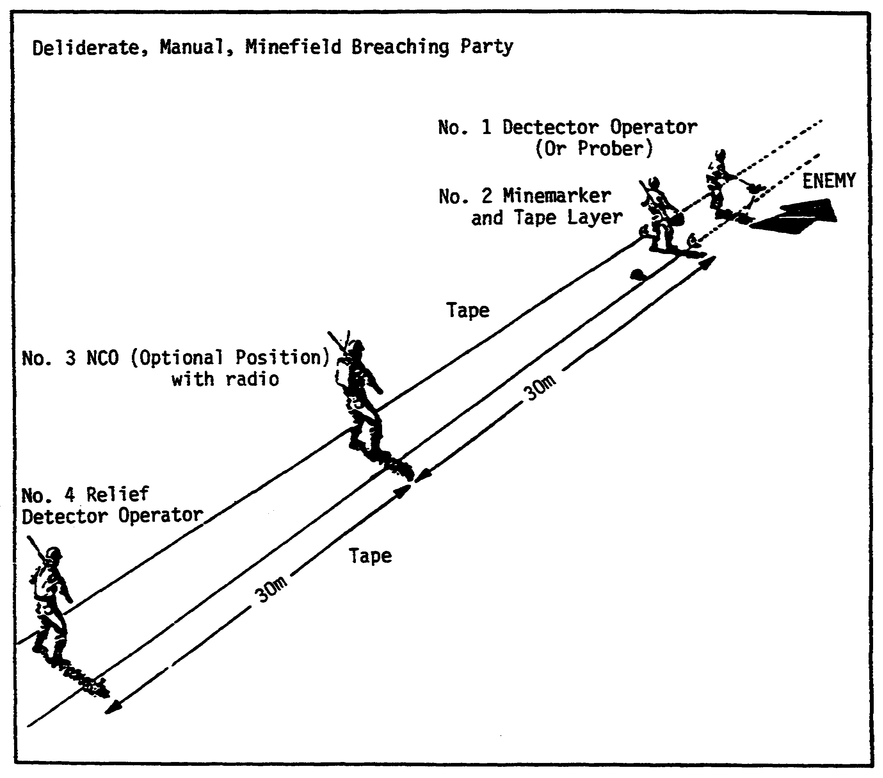

Figure 2: Deliberate, Manual, Minefield Breaching Party

101

Practice Exercise #5

Your unit has been assigned the duty of breaching a minefield. The combat is not in your immediate area and there is no great sense of urgency. The only equipment you have available is your EOD TOE equipment.

As the NCOIC of the team assigned the breaching operation, answer the following questions:

1. How many personnel will you need to operate an effective manual, deliberate minefield breaching party?

2. List the jobs of the personnel you selected for your breaching party.

(1)
(2)
(3)
(4)
(5)

3. Using the following sketch,

(1) Place an X where your team members will be located during the breaching operation and number their positions (i.e., No. 1 man, No. 2 man, etc.).

(2) Mark the width of the sweeping route in meters.

(3) Mark the distance between the 2nd and 3rd and 4th persons.

102

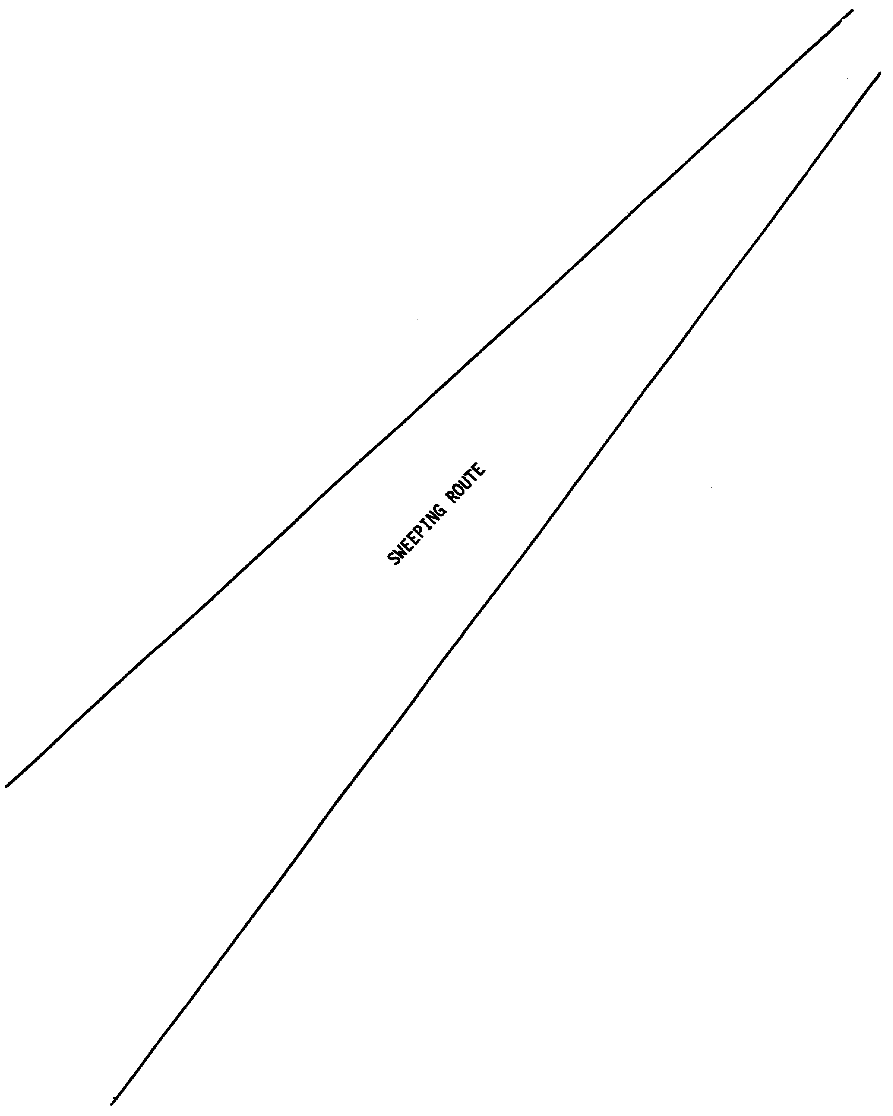

103

Answer to Practice Exercise #5

1. Four people.

2. (1) Yourself/myself as NCOIC to direct operations.

(2) No. 1 Man: Operator of the mine detector or probe.

(3) No. 2 Man: Carries mine markers and probes, and lays the marking tape.

(4) No. 3 Man: NCO (optional position) directs team and communicates OP with NCOIC.

(5) Relief detector operator or prober relief for No. 1 Man.

3. See the sketch on the following page.

104

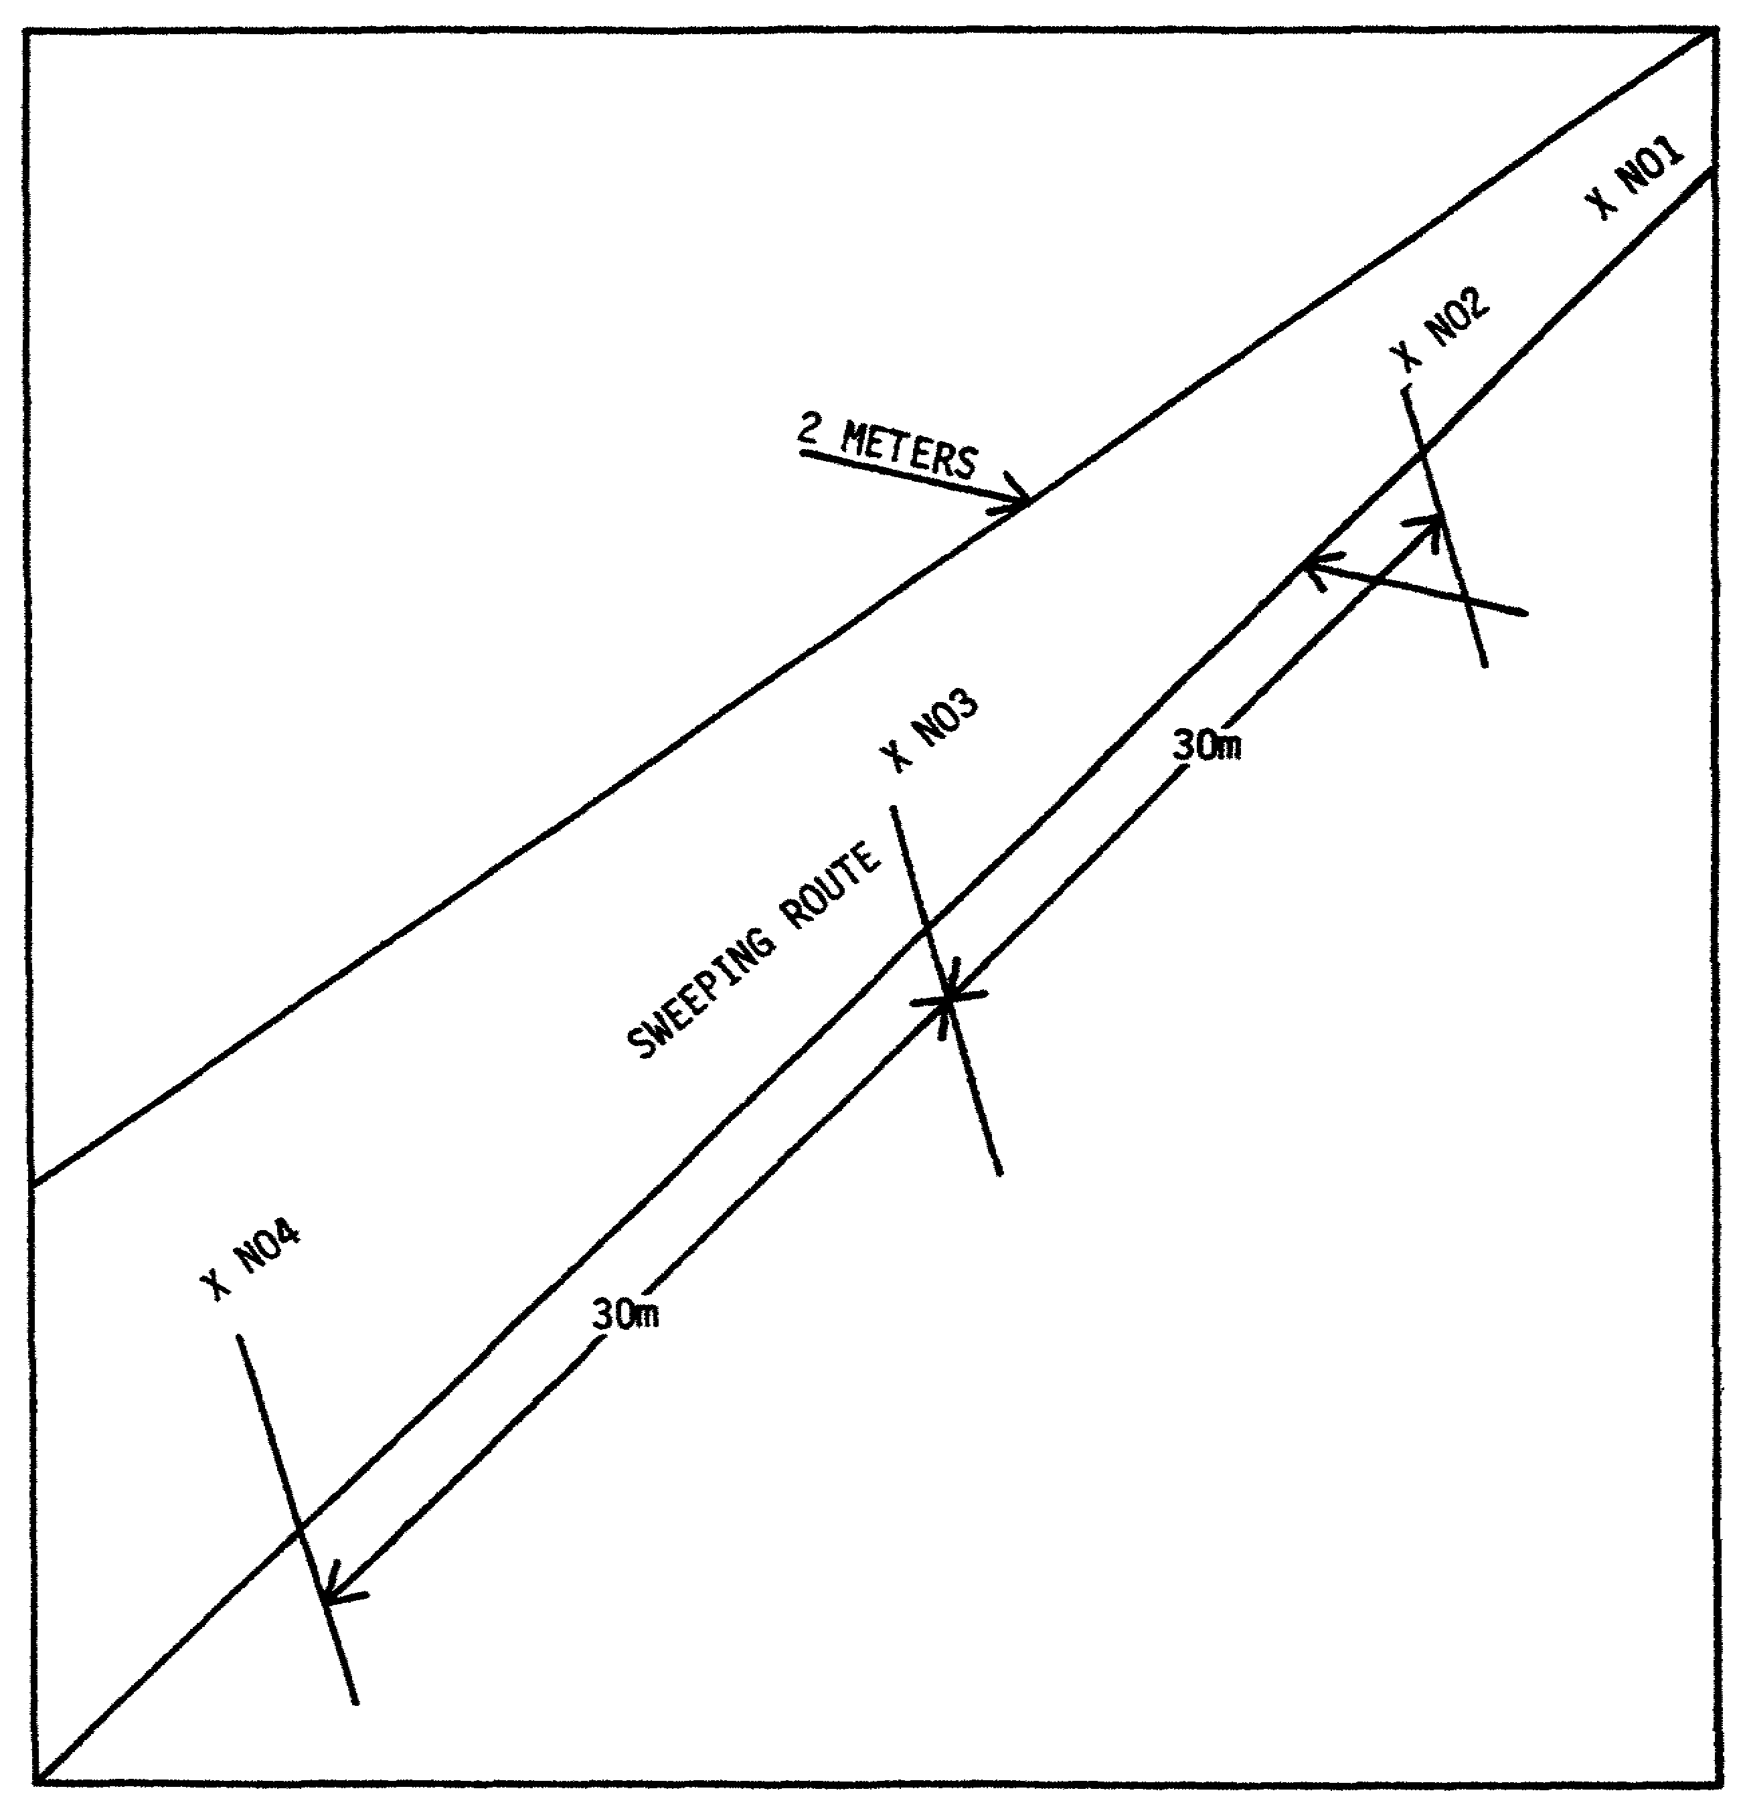

105

Lesson #7 Self-Test

Circle the letter of each correct answer.

1. Who has the primary mission of clearing minefields?

a. EOD

b. engineers

c. military police

2. When a minefield is found, what is the best course of action?

a. manual breaching

b. deliberate clearing with a roller

c. bypassing it

3. Manual breaching:

a. is the best method to use for clearing minefields

b. should only be used during peacetime

c. is a last resort

4. If there is no officer in a minefield breaching party, the NCOIC:

a. leads the way into the minefield

b. moves the party to the starting point and shows them the direction to go.

c. stays at the EOD CP and sends radio messages to the leader of the party.

5. Member No. 1:

a. determines the exact location of the mine

b. marks the mine

c. marks the safe lane

6. Member No. 4:

a. is usually the NCOIC

b. cuts slack tripwires

c. relieves Member No. 1

107

Lesson #7 Self-Test Answers

1. b
If you got this wrong, go back to page 99 and review.

2. c
If you got this wrong, go back to page 99 and review.

3. c
If you got this wrong, go back to page 99 and review.

4. b
If you got this wrong, go back to page 100 and review.

5. a
If you got this wrong, go back to page 100 and review.

6. c
If you got this wrong, go back to page 100 and review.

108

LESSON 8

OBJECTIVE: Prepare Technical Intelligence Reports

TASK: Upon completion of this lesson you will be able to prepare technical intelligence reports.

CONDITIONS: Given this booklet and a pencil.

STANDARDS: Correctly answer all the questions on the Lesson #8 self-test. You must get 100% on the lesson self-test before you take the subcourse examination.

REFERENCES: FM 30-16
DD Form 173

109

LESSON 8

PREPARE TECHNICAL INTELLIGENCE REPORTS

Introduction

In this lesson you will learn how to prepare technical intelligence reports. There is 1 enabling objective in this lesson. You must know how to do this objective.

OBJECTIVE SUBMIT A PRELIMINARY TECHNICAL REPORT ON A ROUND OF
1 OF FOREIGN ORDNANCE

110

OBJECTIVE SUBMIT A PRELIMINARY TECHNICAL REPORT ON A ROUND
1 OF FOREIGN ORDNANCE

1. During the Vietnam War, EOD many times encountered ordnance that had never been seen before. When this happens it is important that information about the new items be reported through channels to the intelligence community so they can analyze any new capabilities of the enemy and get the information to the troops. This same information should be sent to Indian Head for the development of RSPs. One of your duties as supervisor is to make sure that technical intelligence reports are made on "first seen" foreign ordnance.

2. Determine technical intelligence value:

a. Once a munition has been reported or discovered by the EOD team, a reconnaissance and a search of publications has to be performed to determine if the munition is an unknown item.

b. If the munition is unknown to the team members and research of publications turns up no information, then a Preliminary Technical Report (PRETECHREP) is prepared IAW chapter 7, section III, para 7-10b, FM 30-16. This report will be submitted to the EOD Control Unit for distribution to intelligence personnel and other EOD units.

3. The PRETECHREP will be prepared on a DD Form 173 (Joint Message Form) in the following format:

a. First item on the message form:

Date found.
Location (Map Reference).

b. Second item:

Type of equipment and/or munition.
Quantity of equipment and/or munition.

c. Third item:

Origin of item(s).

d. Fourth item:

Brief description of item(s).
Distinguishing marks on the item(s).

e. Fifth item:

Name of the commander of capturing unit.

111

f. Sixth item:

Time of the message.
Origin of the message.

g. Seventh item:

Tentative RSP of the item.

4. If you do not have the information required for one of the items, put the number down and leave the space blank. Additional information such as pictures or sketches should accompany the report. All technical items and paper work will be classified at least Secret. Nuclear items will be Classified Secret Restricted Data.

5. A complementary technical report (COMTECHREP) would normally be made by technical intelligence teams. This is a detailed report on the items and will require much more time to fill out. EOD personnel may be called upon to evaluate ordnance for the preparation of the detailed report. Para 7, FM 30-16 covers the items required on the COMTECHREP.

112

Practice Exercise #6

During the Area Clearance Operation a member of the clearance team has discovered a round of foreign ordnance. Use the following additional information and the drawing on the following page to gather information to prepare your report.

Date: 25 Jan 81
Commander: CPT John Bonner
Time Round Discovered: 0900 hours
Location: Ammo Supply Point # ASP 4 Grid Coord R 212345
Time of Report: 1430 hours

Preliminary Technical Report

1. Date found, location:

2. Type of equipment:

3. Origin:

4. Brief description with distinguishing marks:

5. Technical characteristics with immediate value:

6. Name of commander of capturing unit:

7. Time and origin of the message:

8. Tentative RSP:

113

Answer to Practice Exercise #6

Preliminary Technical Report

1. 25 January 1981

2. Rocket

3. Russian (?)

4. Olive Drab body, gray fuze, red markings

5. Caliber: 260mm
Length: 2460mm
Fins: 4 ea, 90° mounting, 210mm X 195mm
Fuze: Variable Time, marked "C88"
Warhead: Aft section necked down to 220mm with markings “C41-K", 30P, 7
and T".
Rocket Body: Marked with ". . .2" and 4 small, burned venturi in aft plate

6. CPT John Bonner

7. 24/K430, 241st EOD Det

114

Lesson #8 Self-Test

Circle the letter of each correct answer.

1. All technical items and paper work will be classified at least:

a. Classified

b. Secret

c. Top Secret

2. A complementary technical report (COMTECHREP) would normally be made by:

a. the EOD team

b. technical intelligence teams

c. the unit that discovered the ordnance

3. Once a munition has been reported or discovered by the EOD team:

a. it should be immediately reported to intelligence

b. a reconnaissance and a search of publications should be performed

c. it should be destroyed by EOD personnel

4. Which of the following is true?

a. The EOD team reporting on “first seen" ordnance should leave suggesting RSP to intelligence.

b. The EOD team should file both a PRETECHREP and a COMTECHREP.

c. A picture or photo should accompany the PRETECHREP.

115

Lesson #8 Self-Test Answers

1. b
If you got this wrong, go back to page 112 and review.

2. b
If you got this wrong, go back to page 112 and review.

3. b
If you got this wrong, go back to page 111 and review.

4. c
If you got this wrong, go back to page 112 and review.

116

